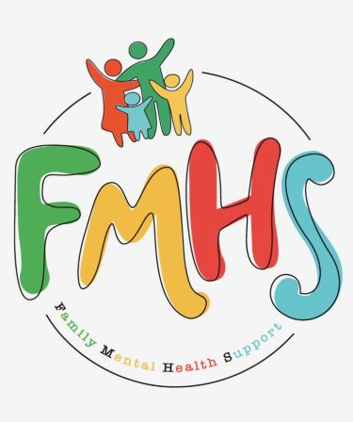

THE LAST MONTH OF AUTUMN AND THE FIRST DAY OF A NEW ADVENTURE!

November can be the start of a stressful holiday season. Please take time for yourself—including getting enough sleep, eating healthy, and exercising. Prioritizing and keeping your attention on the present moment—with no regrets from the past or anxiety about the future—will help you get through the busy holiday season.
Patricia McDaniel, LCSW from the Road Home program, will be our speaker for the November 13th monthly support group. I hope to see you there!
Mama Joe Project –Caregiver movie screening and discussion.
5:15-8pm, Effingham Performance Center.
Have some extra time on your hands? Consider volunteering at our office! Call Sue at:217-821-7737.


Volume 6, Issue 11
Nov 2025

CHAT

FMHS
Susan Elke, President
Sue Heth, V.P.
Maria Soutar, Secretary
Karen Dorn, Treasurer

INSIDE THIS ISSUE
- Patricia McDaniel, speaker for the monthly support grp
- Listen to Your Heart
Nov 5:30-6:30
- Recipe: Crock Pot Chicken
- Library News
- The Invisible Scar
- Chosen Dates
- News From Sue
- QR Code for the Website!!!!

FMHS BOOK FUNDRAISERS

WRITTEN BY LOCAL AUTHORS
Mary Ellen Eversman & Carol Johnson

DRAWN TOGETHER was written by Mary Ellen Eversman. This book recognizes the struggle and need to address children’s mental health issues.
THE HEALING POWER OF WORDS IN RHYME was written by Rev. Carol Johnson. It represents years of “penned” life experiences….a full range of joys and sorrows, ups and downs, challenges and respite points! Hopefully the reader will find comfort and encouragement through the shared life experiences.
The books are available in the FMHS office located at 202 N Banker, Effingham, IL. Drawn Together $8.50, and The Healing Power of Words in Rhyme $20.00. All proceeds go to continuing to provide information, guidance, and resources to our area’s citizens in their time of need!

CROCK POT CHICKEN
Rhonda Schonshack

5-6 chicken thighs or breasts
1 cup chicken broth
Sprinkle above with one package dry ranch dressing.

Cook until fall apart tender – 4-5 hours in crock pot on high.

Shred with two forks, and stir in 8oz cream cheese. Done!!!

Serve on: sandwiches, tacos, rice, salad,…..whatever!

For a more relaxed Holiday meal, start planning a few weeks ahead—thinking about a guest list, the variety of food you want to prepare—remembering to mix up the texture and color of the foods for variety. Stick with simple recipes you feel comfortable making in order to focus on the joy of the occasion

FMHS WEBSITE
QR CODE
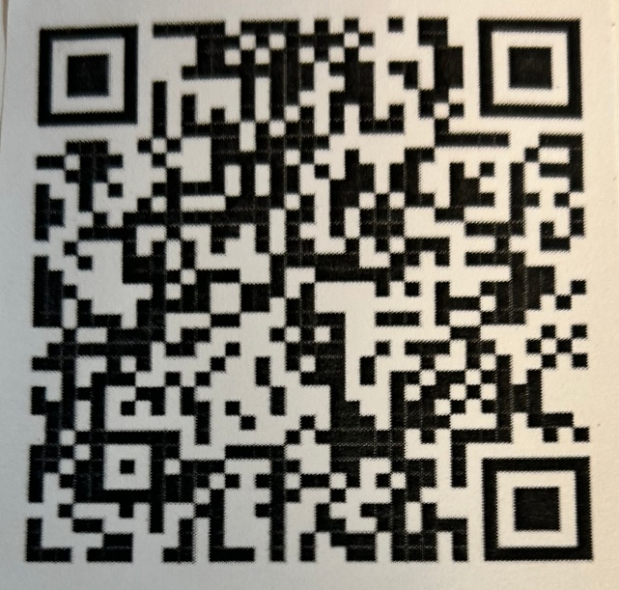

- QR is short for quick response. QR gives you an instant link to a specific webpage.
- Use the QR Code to easily access the CHAT, monthly newsletter.
- It’s easy to pass on to others.

Library news

November 5th – Tech Drop-in
10-11 am Having a problem with your computer, cell phone, or other electronic device? Stop to see Erich Metzelaars, IT consultant. No registration required. 61+ age

November 6th –Puzzle Exchange
10-11am Got a puzzle you’ve solved? Join us for a puzzle exchange! Bring a puzzle you’re ready to part with and trade it for a new-to-you puzzle. No registration required. 61+

WHAT HAS 4 LEGS AND FLIES?
Two pairs of pants!
n
THE INVISIBLE SCAR
Thanks to Barry Jesinoski/DAV Magazine

First recognized in war veterans, PTSD has had many names including “shell shock” and “battle fatigue”. The terms were used to describe the psychological impact of combat.
The DAV (Disabled American Veterans) funded the Forgotten Warrior Project that resulted in PTSD being added to the Diagnostic and Statistical Manual of Mental Disorders.
No matter the source of trauma, the symptoms of PTSD aren’t just clinical criteria. They are reminders of the true cost of service.
Report Medicare Fraud! 1-800-699-9043www.illinoisSMp.org or call Midland Area Agency on Aging; 1-618-532-1853
A HEARTFELT THANKS

To FMHS Volunteers, who have been helping man the office, bringing treats and water to share, dusting, watering plants, mail pick up, and repairs! ...Your contributions keep us going!
Robert McWhorter, Maria Soutar, Susan Elke, Carol Johnson & Chuck Suttle, Patty Winn, Donnie & Karen Dorn, Rhonda & Dail Schonshack, and Luella Baker.
Thanks for the puzzles! They provide hours of entertainment for everyone and the misc. office supplies!

In Kind Contribution: Phone/Sue Heth
Donations:
Culvers –for ice cream for the picnic!
Rural King—for popcorn donation!
Luella Baker—donuts for the Veteran’s Group
DAVA—funding for pizza for Veterans.
Patricia McDaniels—financial donation
Long Term Supporters:
100+ Women Who Care
United Way of Effingham County
OFFICE WISH LIST: Napkins, Folgers coffee, Multi-colored Bic Markers for posters.

MEMORIAL DONATIONS

Ervin Starwalt—Sue Heth
Carol Althoff---Sue Heth

We remember your life, and celebrate the memories”

Save these dates for the CHOSEN:

- “Because of Me” – November 4
- “Reunions” – November 18
- “The Upper Room: Part 1” –December 2
- “The Upper Room: Part 2” –December 16
This historical drama introduces Jesus and the calling and preparation of his initial disciples. You will encounter a very authentic Jesus and will find the flawed crew He gathers, very believable and relatable! We have already seen and discussed the powerful development of each disciple He calls to be a part of the ministry, as shown in Seasons 1, 2, 3, and 4.
To help us prepare for materials and to accommodate you in the office space, consider signing up by contacting the office (217-500-7489), or telling Sue Heth or Carol Johnson. We hope to see you there! We have great discussions!


NOTHING IS IMPOSSIBLE, THE WORD ITSELF SAYS:
“I’M POSSIBLE”
 DATES TO REMEMBER!

November 4, 11, 18, 25……… 10-2pm Office open

November 13 & 27.......... 10-12pm Veterans Support Group ,FMHS Office

November 13th …….……… 5:00-7pm Monthly Support Group, Patricia
McDaniel, speaker re. Mental Health Issues impacting veterans and family

November 27th…………….. Listen to your Heart Group, 5:30-6:30pm, FMHS Office

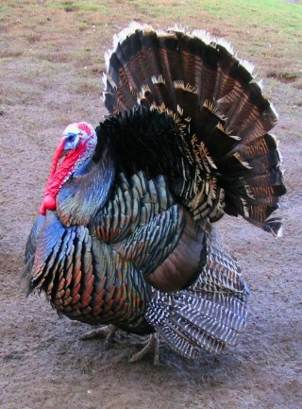
This Photo by Unknown Author is licensed under CC BY-SA

Why did the cranberry blush?
It saw the turkey dressing!
Thanks to 75 Best Thanksgiving Jokes

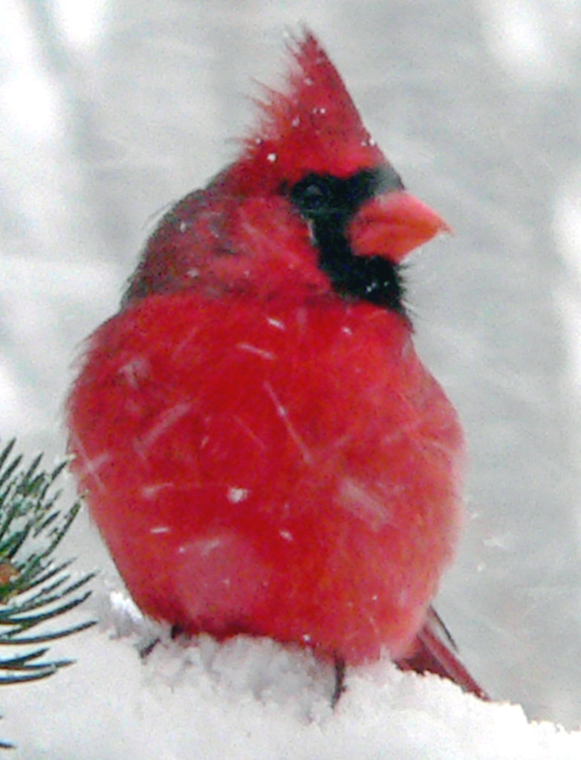
Bird Watching has surprising benefits that soothe the body and mind while connecting you to nature.
- The gentle walking can improve overall fitness.
- Sun exposure helps improve Vit D production essential for bone health and immune function.
- Engaging with nature has a calming effect and is helpful in reducing anxiety.
- Bird watching has been linked to lower levels of depression and anxiety.
- Improved mood and mental health
- Bird watching encourages observation and enhances critical thinking skills
- It encourages mindfulness—focusing on the present moment

The benefits of bird watching can significantly enrich your life.
WINTER BIRD
WATCHING
This Photo by Unknown Author is licensed under CC BY-SA-NC

REMEMBER

November is the month to remind us to be thankful for the many
Positive things happening in your life.

NEWS FROM SUE

Happy Thanksgiving! I hope you will all enjoy the company of good friends and family as well as some delicious food! Taking time daily to contemplate what you are grateful for can help shift your focus from negative thoughts to positive reflections.
Just a reminder: that the FMHS office will be open only on Tuesdays 10-2pm except for trainings, groups, etc. We are still experiencing a volunteer shortage. If you know of anyone that might have 4 hours once a month to volunteer, please have them contact me at 217-821-7737!
Carol and Chuck Suttle and Maria Soutar manned the FMHS Booth at the Volunteer Fair. Thanks for representing FMHS!
THE MONTHLY INSPIRATION GROUP WILL NOT MEET AGAIN UNTIL JANUARY 27TH 1-2PM. WE WILL START A NEW STUDY AT THAT TIME!

Sue Heth

“”
E

You-tube Video – Stop.Look.Go

This 5 min. video helps to take time to appreciate the present moment.
Brother David Steindl-Rast on Gratefulness - Stop. Look. Go.

