

THE LAST MONTH OF AUTUMN AND THE FIRST DAY OF A NEW ADVENTURE!

December always brings a sense of warmth, even on the chilliest days. We hope this season finds you well and ready to enjoy the celebrations ahead.
The Mama Joe Project for caregivers had a pretty good attendance. Hopefully, it helped provide some good ideas as well as needed resources. Thanks to Midland Area Agency on Aging.
I announced at the monthly support group meeting that I have a serious illness that will prevent me from volunteering with FMHS like I enjoy doing. Fortunately, Sonya and Mike Gammon have stepped up to help with the monthly newsletter as well as helping with office coverage.
Have some extra time on your hands? Consider volunteering at our office! Call Sue at:217-821-7737.


Volume 6, Issue 12
Dec. 2025

CHAT

FMHS
Susan Elke, President
Sue Heth, V.P.
Maria Soutar, Secretary
Karen Dorn, Treasurer

INSIDE THIS ISSUE
- Christmas Party
- Listen to Your Heart
January 22, 5:30-6:30
- Recipe: Carol’s Pumpkin Dessert
- The Old rocking Chair by Rev. Carol Johnson
- Winter Bird Watching
- Chosen Dates
- News From Sue
- QR Code for the Website!!!!

FMHS BOOK FUNDRAISERS

WRITTEN BY LOCAL AUTHORS
Mary Ellen Eversman & Carol Johnson

DRAWN TOGETHER was written by Mary Ellen Eversman. This book recognizes the struggle and need to address children’s mental health issues.
THE HEALING POWER OF WORDS IN RHYME was written by Rev. Carol Johnson. It represents years of “penned” life experiences….a full range of joys and sorrows, ups and downs, challenges and respite points! Hopefully the reader will find comfort and encouragement through the shared life experiences.
The books are available in the FMHS office located at 202 N Banker, Effingham, IL. Drawn Together $8.50, and The Healing Power of Words in Rhyme $20.00. All proceeds go to continuing to provide information, guidance, and resources to our area’s citizens in their time of need!

Carol’s Pumpkin Dessert
Thanks to Rev. Carol Johnson

1 large can pumpkin
6 eggs
1 (12oz) can evaporated milk
1 tsp pumpkin pie spice
Beat together in large bowl and pour into greased large glass bake dish
1 box spice cake mix
1 stick butter
1 tub cheesecake cream cheese
Sprinkle cake mix on top of pumpkin mixture and add squares of butter on top
Add dollops of cream cheese on top
Bake at 350 for 50-55min

FMHS WEBSITE
QR CODE


- QR is short for quick response. QR gives you an instant link to a specific webpage.
- Use the QR Code to easily access the CHAT, monthly newsletter.
- It’s easy to pass on to others.

Report Medicare Fraud! 1-800-699-9043www.illinoisSMp.org or call Midland Area Agency on Aging; 1-618-532-1853
A HEARTFELT THANKS

To FMHS Volunteers, who have been helping man the office, bringing treats and water to share, dusting, watering plants, mail pick up, and repairs! ...Your contributions keep us going!
Robert McWhorter, Maria Soutar, Susan Elke, Carol Johnson & Chuck Suttle, Patty Winn, Donnie & Karen Dorn, Rhonda & Dail Schonshack, and Luella Baker.
Thanks for the puzzles! They provide hours of entertainment for everyone and the misc. office supplies!

In Kind Contribution: Phone/Sue Heth
Donations:
Luella Baker—donuts for the Veteran’s Group
DAVA—funding for pizza for Veterans.
Katie Wernsing: Candy for the office
Bob McWhorter: coffee
Long Term Supporters:
100+ Women Who Care
United Way of Effingham County
OFFICE WISH LIST: Napkins, Multi-colored Bic Markers --for posters.

MEMORIAL DONATIONS

We remember your life, and celebrate the memories”

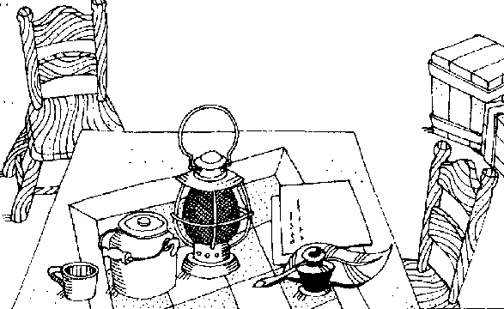
Be careful not to forget the things you have seen God do for you. Keep reminding yourself, and tell your children and grandchildren, too.” Deuteronomy

December 2025

“The Old Rocking Chair” by Carol Johnson

The auctioneer was thrilled that the first week in December would yield such inviting weather, would yield curious potential buyers to the sale of the old man’s household goods. It was a sunny Sunday afternoon, and the young mother had drifted into the crowd with what she knew was a laughable amount she could spend. That chair would help out, and that box of books seemed certainly valuable to one who loved books as much as she. And when the bidding began, she was amazed that others did not see the value of that old rocking chair, painted shiny black, sitting isolated, with a story to tell.
And later smiling from deep within, she tucked the $5 chair into the trunk of her old station wagon, along with the box of books and two paintings, which cost only an additional $2. The single mother returned to her five children with the treasures. The chair would become a warm and soothing place in the darkness of that time, and the books and two paintings of Jesus would bring the ringing of hope to the expectant hearts and minds of her children as well. Even then, she could marvel that $7 could bring such enlightenment and comfort.
The chair is well over 100 years old now. That sweet old man from our little town had died, a devout member of the local Lutheran church, loved and respected in the community. His personal things sold at auction, and the items I bought became a blessing to me and my children several years ago, and still are treasures. That man’s life commitment to the church was reflected in a box of Bible study materials, German Bibles, Lutheran catechisms, and two lovely paintings of Jesus. His World War II New Testament was included in the box, with the name of the chaplain who gave it to him. His love for the Bible, his love for the Church, his love for Jesus, were all there, as a witness to me, when my life felt so broken and depleted.
As I rocked in the chair, I began to read the old man’s Lutheran catechism. And when I first read about Martin Luther, I cried for hours, reflecting on all he had endured to attempt to preserve the sanctity of the Church he loved so much. The story of Luther was all new to me, at the time.
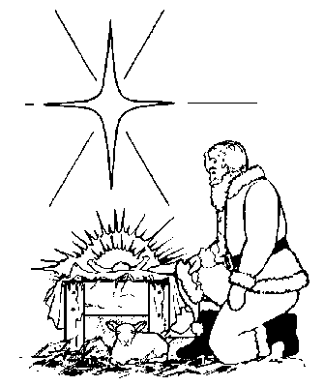
A few years ago, I stripped off the peeling black enamel on that old rocking chair and carefully sanded and refinished it, bringing to light the lovely possibilities and natural beauty of the wood beneath, hidden for years. And my dear friend Pete (who is now with the Lord) brought new breath and spirit to the chair with his repairs and woodworking skill. My beloved (now deceased) husband, Jim, also faithfully helped me to sand and clean the various parts scattered about, in order to give it new life.
A new season had begun for the chair. It will last to serve another generation, and another... It is still in my home, to this day.
Advent (the four weeks prior to Christmas) helps us see the Christmas season in a similar light as I once saw that old rocking chair long ago. Precious and often in need of maintenance, renewal, loving care, our spiritual lives are preserved for the needs of the next generation for God’s grace, needing the glue of the Holy Spirit, and the glaze of grace from Word and Sacrament, inviting the wise handiwork of Jesus to ensure it is put together correctly, polishing the old, to enhance its natural beauty and character, with new parts as needed! A tool for “strengthening rest” in our time of waiting, the Church gives us Advent which brings us into the Christmas season with new calm and awareness!
And we will rest and pray and rock away the worries as we absorb the peace of a solid place to dwell for a while, each time we enter the “sacred space” of Church. With a thankful heart, I think of you, and that old gentleman who long ago left evidence and witness of his faith and character, not knowing how it led to hope and renewal for me. I thank God for that rocking chair! Another place of peace and renewal in times of weariness of the body and spirit. A treasure, so much like our connection with God…

Note from Sue: That is a beautiful story, Carol. I, too, have a $2 auction item –a beautiful oak table that had been painted-- with linoleum glued on the top. Unlike you, I don’t know the history but I can imagine many mouths being fed from that table! I’ve had it since 1970, so well over 50 years old!

Save these dates for the CHOSEN:

- “The Upper Room: Part 1” –December 2
- “The Upper Room: Part 2” –December 16
This historical drama introduces Jesus and the calling and preparation of his initial disciples. You will encounter a very authentic Jesus and will find the flawed crew He gathers, very believable and relatable! We have already seen and discussed the powerful development of each disciple He calls to be a part of the ministry, as shown in Seasons 1, 2, 3, and 4.
To help us prepare for materials and to accommodate you in the office space, consider signing up by contacting the office (217-500-7489), or telling Sue Heth or Carol Johnson. We hope to see you there! We have great discussions!

 DATES TO REMEMBER!

December 2,9,16,23,30……… 10-2pm Office open
December 11th.................. 10-12pm Veterans Support Group ,FMHS Office
December 11th …….……… 5:00-7pm (Christmas Party Monthly Support Group)
NOTE: SOME GROUPS ARE CANCELLED DUE TO CHRISTMAS!


This Photo by Unknown Author is licensed under CC BY
December: A month of lights, snow, coziness, and feasts; time to make amends and tie up loose ends.; finish what you started and make your wishes come true.”
Author Unknown

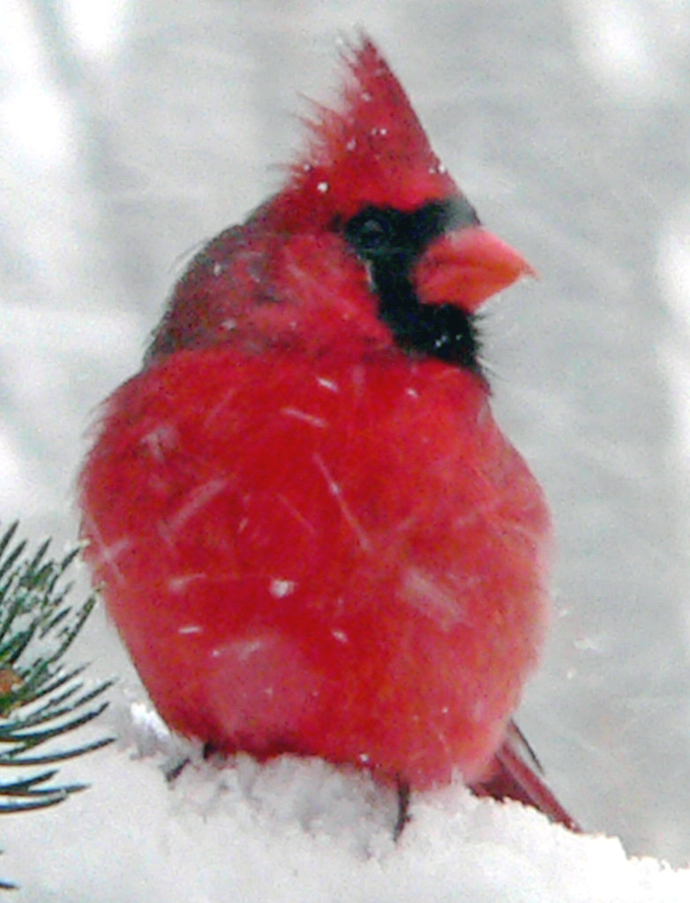
Bird Watching has surprising benefits that soothe the body and mind while connecting you to nature.
- The gentle walking can improve overall fitness.
- Sun exposure helps improve Vit D production essential for bone health and immune function.
- Engaging with nature has a calming effect and is helpful in reducing anxiety.
- Bird watching has been linked to lower levels of depression and anxiety.
- Improved mood and mental health
- Bird watching encourages observation and enhances critical thinking skills
- It encourages mindfulness—focusing on the present moment

The benefits of bird watching can significantly enrich your life.
WINTER BIRD
WATCHING
This Photo by Unknown Author is licensed under CC BY-SA-NC

REMEMBER

DECEMBER brings so much good feeling, creates happiness, laughter and joy. I pray this December shall be beautiful and blissful.
Author unknown

NEWS FROM SUE

Holiday Greetings!
It is with regret that I have to step down from some of my volunteer activities with FMHS. Thankfully, others are stepping up.
Effingham county is remarkable for the numerous holiday opportunities. If you haven’t seen the decorations around the old court house, take time to walk or drive past. The Cross has a lovely Nativity Display. There are many from different countries. The important thing is to not miss the opportunity for bringing joy into your life during the holidays.

Reminder: THE MONTHLY INSPIRATION GROUP WILL NOT MEET AGAIN UNTIL JANUARY 27TH 1-2PM. WE WILL START A NEW STUDY AT THAT TIME!
Sue Heth

“”
E

You-tube Video – Stop.Look.Go

This 5 min. video helps to take time to appreciate the present moment.
Brother David Steindl-Rast on Gratefulness - Stop. Look. Go.

