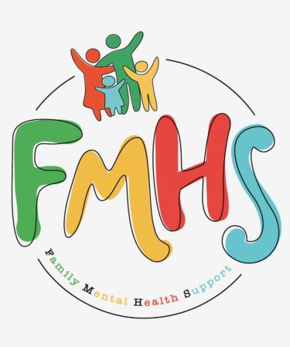

THE FIRST MONTH OF THE YEAR AND THE FIRST DAY OF A NEW ADVENTURE!

We hope everyone had a wonderful holiday season and that this finds you well and ready to start a new exciting year.

Due to serious health concerns, Sue is prevented from volunteering with FMHS like she enjoys doing, but will remain behind the scenes. Fortunately, Sonya and Mike Gammon have stepped up to help with the monthly newsletter as well as helping with office coverage. She is fighting this illness like the warrior she is.

Have some extra time on your hands? Consider volunteering at our office! Call Sue at:217-821-7737.


Volume 7, Issue 1
Jan. 2026

CHAT

FMHS
Susan Elke, President
Sue Heth, V.P.
Maria Soutar, Secretary
Karen Dorn, Treasurer

INSIDE THIS ISSUE

- HAPPY NEW YEAR
- Book Fundraiser
- Recipe: Simmer Pots
- KINDNESS By Greg Hook
- Martin Luther King Jr Day
- Memorials
- News From Sonya & Mike
- QR Code for the Website!!!!

FMHS BOOK FUNDRAISERS

WRITTEN BY LOCAL AUTHORS
Mary Ellen Eversman & Carol Johnson

DRAWN TOGETHER was written by Mary Ellen Eversman. This book recognizes the struggle and need to address children’s mental health issues.
THE HEALING POWER OF WORDS IN RHYME was written by Rev. Carol Johnson. It represents years of “penned” life experiences….a full range of joys and sorrows, ups and downs, challenges and respite points! Hopefully the reader will find comfort and encouragement through the shared life experiences.
The books are available in the FMHS office located at 202 N Banker, Effingham, IL. Drawn Together $8.50, and The Healing Power of Words in Rhyme $20.00. All proceeds go to continuing to provide information, guidance, and resources to our area’s citizens in their time of need!

SIMMER POTS

Thanks to: Cindy McCune

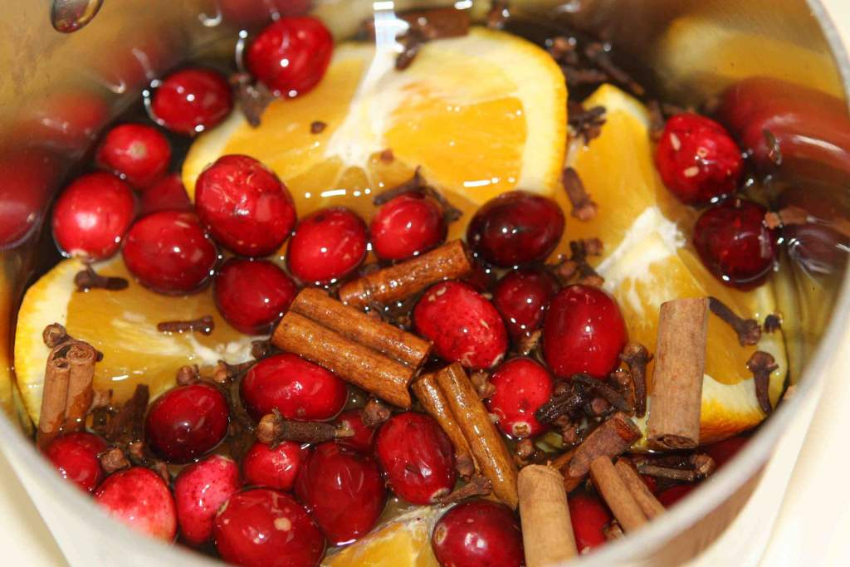
This Photo by Unknown Author is licensed under CC BY-NC-ND

1 tsp whole cloves
3-4 star anise
3-4 cinnamon sticks
1/3rd c cranberries
1 orange
Cute pastry bags and twine for bow on top.

Cut orange into slices. Add all ingredients and cover with water. Simmer on stove and enjoy.

FMHS WEBSITE
QR CODE
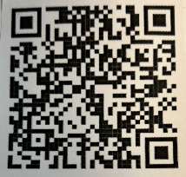

- QR is short for quick response. QR gives you an instant link to a specific webpage.
- Use the QR Code to easily access the CHAT, monthly newsletter.
- It’s easy to pass on to others.

A HEARTFELT THANKS

To FMHS Volunteers, who have been helping man the office, bringing treats and water to share, dusting, watering plants, mail pick up, and repairs! ...Your contributions keep us going!
Robert McWhorter, Maria Soutar, Susan Elke, Carol Johnson & Chuck Suttle, Patty Winn, Donnie & Karen Dorn, Rhonda & Dail Schonshack, and Luella Baker.
Patricia McDaniels for the coffee pots, coffee & supplies, office supply donations.
Thanks for the puzzles! They provide hours of entertainment for everyone and the misc. office supplies!

MARTIN LUTHER KING JR --- JAN.19, 2026
Martin Luther King Jr. was a Baptist minister and major leader of the Civil Rights Movement. After his assassination, he was memorialized by Martin Luther King Jr. Day.
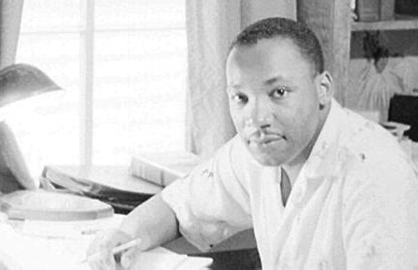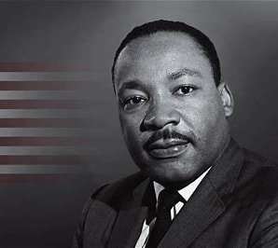

“If you can’t fly, run; if you can’t run, walk; if you can’t walk, crawl, but whatever you do you have to keep moving forward.” ~Martin Luther King Jr.

You-tube Video – Kindness Matters
https://youtu.be/Qcyc68d6OAk

This 1 min. video helps to explain how kindness helps improve mental health.
By the Mental Health Foundation

Always remember that your present situation is not your final destination. The best is yet to come—keep moving forward. Author unknown

KINDNESS
By Greg Hook

KINDNESS, most people want to be seen, to be acknowledged as real and worthy in that moment. A simple “how are you doing today” can soften someone’s armor because it signals presence, not judgement.
KINDNESS is not grand gestures. It’s attention. It’s pausing long enough to even quietly, you create safety. And safety is where people exhale, where healing begins, where walls come down.
Being kind doesn’t mean carrying everyone’s burdens. It means meeting people with respect, patience, and curiosity instead of assumption. When you do that, you remind them they are not invisible. And often, that reminder is enough to change the tone of the entire day, sometimes even a life.

MEMORIAL DONATIONS

RUSS HOWARD BY Sue Heth

RANDAL ABRAHAM BY Midland Area Agency on Aging
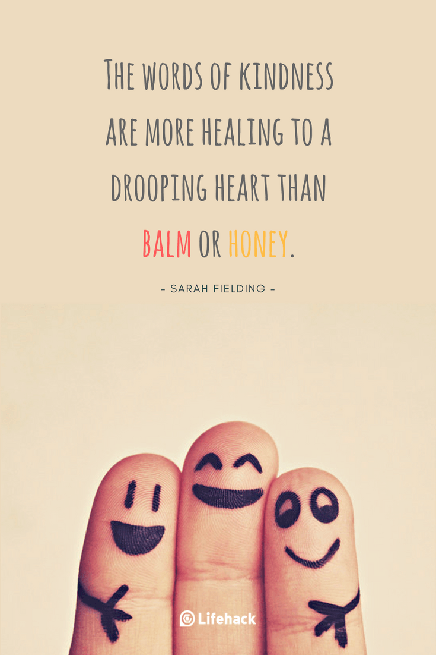
In Kind Contribution: Phone/Sue Heth
Donations:
Luella Baker—donuts for the Veteran’s Group
DAVA—funding for pizza for Veterans.
Bob McWhorter: coffee
Long Term Supporters:
100+ Women Who Care
United Way of Effingham County
OFFICE WISH LIST: Napkins, Multi-colored Bic Markers --for posters.



DATES TO REMEMBER!

January 6, 13, 20, 27 …………. 10-2pm Office open

January 7th and 21st …………… The Society for Better Men Group, FMHS Office 7pm

January 8th and 22nd ............ 10-12pm Veterans Support Group, FMHS Office

January 8th …………….……………… FMHS Monthly Support Group, First Baptist Church of
Effingham

January 22nd …………………………. Listen to your Heart Discussion Group, 5:30-6:30pm
by Greg Hook, FMHS Office

NOTE: SOME GROUPS MAY BE CANCELLED DUE TO INCLEMENT WEATHER

“Each year’s regrets are envelopes in which messages of hope are found for the new year.” ~ John R Dallas

NEWS FROM SONYA

Happy New Year!

We are Mike and Sonya Gammon, we learned about FMHS while attending the Volunteer Fair at the Effingham Public Library. We have recently moved to Effingham. Mike and I spent the last 20+ years providing care for the Missouri Department of Mental Health. We moved here to help care for family and enjoy volunteering in our free time.
It has been great meeting so many people who also volunteer their time, sharing the same desire to help others. We have 4 cats that keep us entertained. Both of us received degrees in Therapeutic Recreation and Rehabilitation Administration at SIU Carbondale before marrying and moving to Missouri.

Reminder: THE MONTHLY INSPIRATION GROUP WILL NOT MEET UNTIL SUE RETURNS. WE WILL START A NEW STUDY AT THAT TIME! ~Sue Heth

Jokes:

What does a gingerbread man put on his bed?
Cookie Sheets

What did the icy road say to the car?
"Want to go for a spin?”

