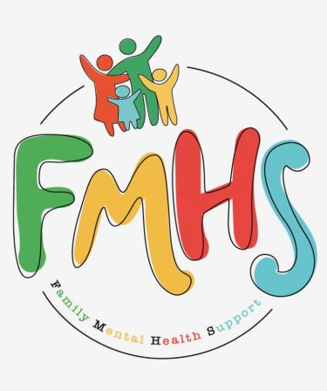

Volume 7, Issue 3
March 2026

CHAT

THE NEW YEAR HAS BROUGHT NEW HOURS!! THE OFFICE WILL NOW BE OPEN TUESDAYS & WEDNESDAYS 10-2.

We have some exciting news, new groups, and local events to share this month. These are listed in the Dates to Remember.

Have some extra time on your hands? Consider volunteering at our office! Call Sue at:217-821-7737.

FMHS
Susan Elke, President
Sue Heth, V.P.
Maria Soutar, Secretary
Karen Dorn, Treasurer

INSIDE THIS ISSUE

- NEW HOURS
- Book Fundraiser
- Recipe: Leprechaun Bait
- Donations
- Dates to Remember
- QR Code for the Website!!!!

General Primary Election is 3-17-26
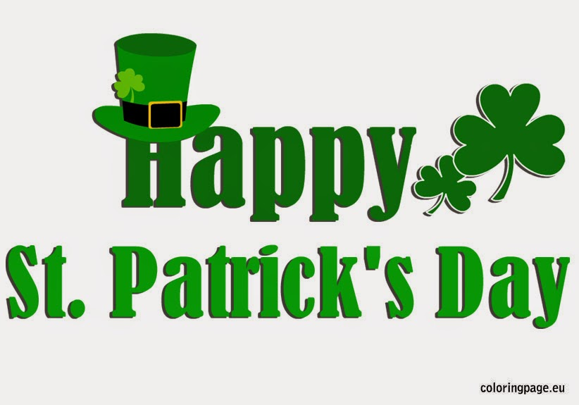
This Photo by Unknown Author is licensed under CC BY-NC-ND

FMHS BOOK FUNDRAISERS

WRITTEN BY LOCAL AUTHORS
Mary Ellen Eversman & Carol Johnson

DRAWN TOGETHER was written by Mary Ellen Eversman. This book recognizes the struggle and need to address children’s mental health issues.
THE HEALING POWER OF WORDS IN RHYME was written by Rev. Carol Johnson. It represents years of “penned” life experiences….a full range of joys and sorrows, ups and downs, challenges and respite points! Hopefully the reader will find comfort and encouragement through the shared life experiences.
The books are available in the FMHS office located at 202 N Banker, Effingham, IL. Drawn Together $8.50, and The Healing Power of Words in Rhyme $20.00. All proceeds go to continuing to provide information, guidance, and resources to our area’s citizens in their time of need!

REMINDER:

Effingham Public Library has many events free to attend!
Amanda McKay, Library Director will be our guest speaker @ Monthly Meeting 3/12/26

Leprechaun Bait
From: Chelsea Lords

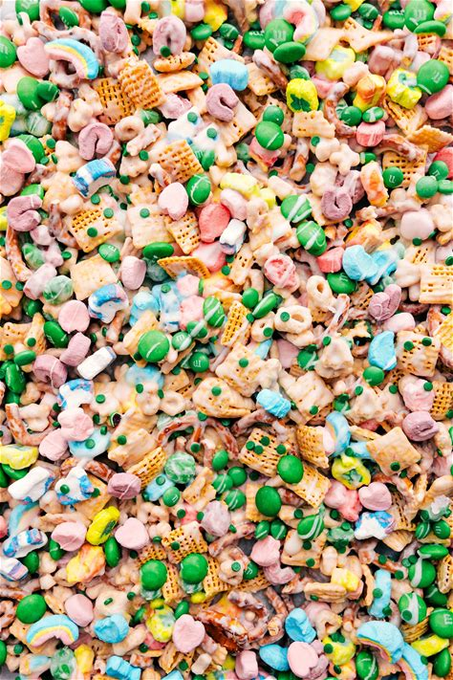

INGREDIENTS:
- 2 cups Corn Chex cereal or Rice Chex
- 1 cup mini pretzel twists
- 1-1/2 cups Lucky Charms cereal
- 1/2 cup Lucky Charms marshmallows pick out of cereal
- 3/4 cup green M&M’s or other candy-coated chocolate, divided
- 1 (11-ounce) bag white chocolate chips
- 1-1/2 teaspoons vegetable oil
Line a large sheet pan with parchment paper and set aside.
In a large bowl, combine corn Chex, pretzels, Lucky Charms, Lucky Charms marshmallows, and 1/2 cup green M&M’s.
In a microwave-safe bowl, add the white chocolate chips and vegetable oil. Microwave for 30 seconds, stir, and microwave for another 25 seconds. Stir until melted and smooth. If necessary, return to the microwave a little longer. (Use bursts of 10 seconds, stirring for 10 seconds between each burst). Pour the melted and smooth white chocolate over the snack mix.
Gently stir until completely combined, then transfer to the prepared sheet pan and spread into an even layer. Add remaining 1/4 cup M&M’s on top.
Allow to harden at room temperature or place in the fridge until firm, about 10–20 minutes. Break into pieces and serve

FMHS WEBSITE
QR CODE
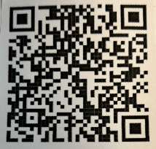

- QR is short for quick response. QR gives you an instant link to a specific webpage.
- Use the QR Code to easily access the CHAT, monthly newsletter.
- It’s easy to pass on to others.

A HEARTFELT THANKS

To FMHS Volunteers, who have been helping man the office, bringing treats and water to share, dusting, watering plants, mail pick up, and repairs! ...Your contributions keep us going!
Robert McWhorter, Maria Soutar, Susan Elke, Carol Johnson & Chuck Suttle, Patty Winn, Donnie & Karen Dorn, Rhonda & Dail Schonshack, and Luella Baker.
Thanks for the puzzles! They provide hours of entertainment for everyone and the misc. office supplies!

In Kind Contribution: Phone/Sue Heth
Donations:
Loella Baker—donuts for the Veteran’s Group
DAVA—funding for pizza for Veterans.
Bob McWhorter: coffee
Mike & Sonya: Art & Crafts supplies
Long Term Supporters:
100+ Women Who Care
United Way of Effingham County
OFFICE WISH LIST:
Napkins, Multi-colored Bic Markers --for posters.

MONETARY DONATIONS
PEO Women’s Group

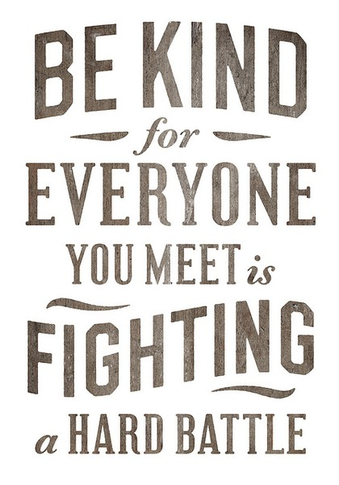
This Photo by Unknown Author is licensed under CC BY-NC-ND


DATES TO REMEMBER!

March 3, 4, 10, 11, 17, 18, 24, 25 & 31 ………….10-2pm Office open

March 4th ….”Invite the Healing”—Music Therapy by Carol Johnson—5-7pm @
FMHS Office

March 10th……..”Invite the Healing”—Art Therapy by Carol Johnson—5-7pm @
FMHS Office

March 5, 12, & 19 …………….. AARP Tax Prep, 9-4pm, Effingham Public Library,
Beuer Room

March 10th and 24th ……………The Society for Better Men Group, FMHS Office 7pm

March 12th and 26th ............10-12pm Veterans Support Group, FMHS Office

March 12th …..FMHS Monthly Support Group, 5:30-7:00pm, First Baptist Church of
Effingham—Guest Speaker, Amanda McKay-Effingham Public
Library Director
March 3, 10, 17, 24,& 31st ………………Anxiety/Mood Support Group, 5:30-6:30pm,
Effingham Public Library-Basement

March 24th ………………………….. Inspiration Discussion Group, 1-2p, FMHS Office

March 26th ………………………….Listen to your Heart Discussion Group, 5:30-6:30pm
by Greg Hook, FMHS Office

NOTE: SOME GROUPS MAY BE CANCELLED DUE TO INCLEMENT WEATHER

