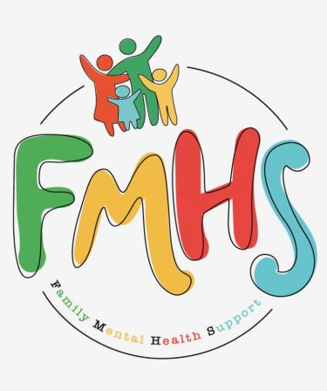

Volume 7, Issue 4
April 2026

CHAT

THE NEW YEAR HAS BROUGHT NEW HOURS!! THE OFFICE WILL NOW BE OPEN TUESDAYS & WEDNESDAYS 10-2.

We have some exciting news, new groups, and local events to share this month. These are listed in the Dates to Remember.

Have some extra time on your hands? Consider volunteering at our office! Call Sue at:217-821-7737.

FMHS
Susan Elke, President
Sue Heth, V.P.
Maria Soutar, Secretary
Karen Dorn, Treasurer

INSIDE THIS ISSUE

- NEW HOURS
- Book Fundraiser
- Recipe: 1974 Unforgettable Watergate Cake
- Donations
- Dates to Remember
- QR Code for the Website!!!!


This Photo by Unknown Author is licensed under CC BY-ND

FMHS BOOK FUNDRAISERS

WRITTEN BY LOCAL AUTHORS
Mary Ellen Eversman & Carol Johnson

DRAWN TOGETHER was written by Mary Ellen Eversman. This book recognizes the struggle and need to address children’s mental health issues.
THE HEALING POWER OF WORDS IN RHYME was written by Rev. Carol Johnson. It represents years of “penned” life experiences….a full range of joys and sorrows, ups and downs, challenges and respite points! Hopefully the reader will find comfort and encouragement through the shared life experiences.
The books are available in the FMHS office located at 202 N Banker, Effingham, IL. Drawn Together $8.50, and The Healing Power of Words in Rhyme $20.00. All proceeds go to continuing to provide information, guidance, and resources to our area’s citizens in their time of need!

FMHS WEBSITE
QR CODE
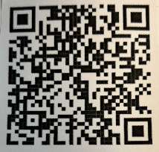

- QR is short for quick response. QR gives you an instant link to a specific webpage.
- Use the QR Code to easily access the CHAT, monthly newsletter.
- It’s easy to pass on to others.

1974 Unforgettable Watergate Cake by Karen Dorn

INGREDIENTS:
1 box white cake mix 1 pkg instant pistachio pudding
1 cup oil 3 eggs
1 cup club soda ½ cup chopped nuts
Mix cake mix and pudding. Add eggs, oil, nuts and soda. Mix well and beat for 4 minutes at medium speed. Grease and flour bundt pan. Bake @ 350 degrees for 1 hour. Cool 20 minutes and frost with Watergate frosting. Can be baked in 9 x 13 pan for 40 minutes.
1974 UNFORGETABLE WATERGATE FROSTING:
1 pkg dream whip 1 cup plus 1 tsp. cold milk
1 box instant pistachio pudding coconut and maraschino cherries
Blend dream whip and milk. Gradually add pudding while mixing. Beat 2 minutes. Put on cake and sprinkle with coconut and decorate with cherries.

RESOURCES FOR LYING:

- Cleveland Clinic: How to Handle Your Child's Lying at Every Age
- American Psychological Association (APA): The Truth About Lies
- Very Well Mind: How to Understand and Cope With Compulsive Liars
- Psychology Today: The Psychology and Impact of Lying and Self-Deception
- Science Direct: The Psychology of Lying

A HEARTFELT THANKS

To FMHS Volunteers, who have been helping man the office, bringing treats and water to share, dusting, rearranging furniture, watering plants, mail pick up, and repairs! ...Your contributions keep us going!
Robert McWhorter, Maria Soutar, Susan Elke, Carol Johnson & Chuck Suttle, Patty Winn, Donnie & Karen Dorn, Rhonda & Dail Schonshack, and Luella Baker.
Thanks for the puzzles! They provide hours of entertainment for everyone and the misc. office supplies!
Special thanks to Greg Hook & Ron Pearce for assisting with March “Invite the Healing” sessions with Carol Johnson.

In Kind Contribution: Phone/Sue Heth
Donations:
Loella Baker—donuts for the Veteran’s Group
DAVA—funding for pizza for Veterans.
Bob McWhorter: coffee
Mike & Sonya: Art & Crafts supplies
Long Term Supporters:
100+ Women Who Care
United Way of Effingham County
OFFICE WISH LIST:
Napkins, Multi-colored Bic Markers --for posters.



DATES TO REMEMBER!

April 1, 7, 8, 14, 15, 21, 22, 28 & 29 ………….10-2pm Office open

April 8th ….”Invite the Healing”—Aroma Therapy by Carol Johnson—5-7pm @
FMHS Office

April 13th……..”Invite the Healing”—Plant Therapy by Carol Johnson—5-7pm @
FMHS Office

April 5, 12, & 19 …………….. AARP Tax Prep, 9-4pm, Effingham Public Library,
Beuer Room

April 14th and 28th ……………The Society for Better Men Group, FMHS Office 7pm

April 9^{h} and 23rd ............10-12pm Veterans Support Group, FMHS Office

April 9th …..FMHS Monthly Support Group, 5:30-7:00pm, First Baptist Church of
Effingham—Guest Speaker, Linda Heynen—Illinois Master Gardener
April 7, 14, 21 & 28th ………………Anxiety/Mood Support Group, 5:30-6:30pm,
Effingham Public Library-Basement

April 28th ………………………….. Inspiration Discussion Group, 1-2p, FMHS Office

April 23rd ………………………….Listen to your Heart Discussion Group, 5:30-6:30pm
by Greg Hook, FMHS Office

NOTE: SOME GROUPS MAY BE CANCELLED DUE TO INCLEMENT WEATHER


This Photo by Unknown Author is licensed under CC BY-SA

Come learn about “Teacup Gardening”

Courtesy of
Linda Heynen, Master Gardener

Presentation will be held on Thursday, April 9th, 2026, from 5:30-6:30 pm @ First Baptist Church.

Come join us and get your hands dirty!


