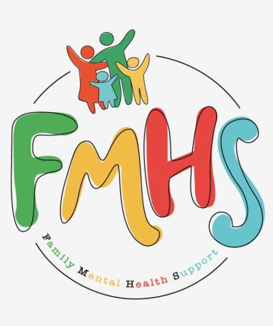

Volume 7, Issue 5
May 2026

CHAT

THE NEW YEAR HAS BROUGHT NEW HOURS!! THE OFFICE WILL NOW BE OPEN TUESDAYS & WEDNESDAYS 10-2.

May is Mental Health Awareness Month!

Mother’s Day is May 10th

May is National Military Appreciation Month

Have some extra time on your hands? Consider volunteering at our office! Call Sue at:217-821-7737.

FMHS
Susan Elke, President
Sue Heth, V.P.
Maria Soutar, Secretary
Karen Dorn, Treasurer

INSIDE THIS ISSUE

- NEW HOURS
- Book Fundraiser
- Recipe: Quick Pineapple Angel Food Cake
- Donations
- Dates to Remember
- QR Code for the Website!!!!

Inspirational Group will not meet for May 2026.



This Photo by Unknown Author is licensed under CC BY-NC-ND

MEMORIALS

Marsha Thomas
Michael Baker
FMHS BOOK FUNDRAISERS

WRITTEN BY LOCAL AUTHORS
Mary Ellen Eversman & Carol Johnson

DRAWN TOGETHER was written by Mary Ellen Eversman. This book recognizes the struggle and need to address children’s mental health issues.
THE HEALING POWER OF WORDS IN RHYME was written by Rev. Carol Johnson. It represents years of “penned” life experiences….a full range of joys and sorrows, ups and downs, challenges and respite points! Hopefully the reader will find comfort and encouragement through the shared life experiences.
The books are available in the FMHS office located at 202 N Banker, Effingham, IL. Drawn Together $8.50, and The Healing Power of Words in Rhyme $20.00. All proceeds go to continuing to provide information, guidance, and resources to our area’s citizens in their time of need!

FMHS WEBSITE
QR CODE
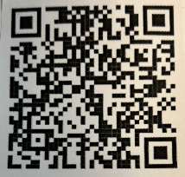

- QR is short for quick response. QR gives you an instant link to a specific webpage.
- Use the QR Code to easily access the CHAT, monthly newsletter.
- It’s easy to pass on to others.

Quick Pineapple Angel Food Cake By Jean Wiyatt

- INGREDIENTS:
- 1 box Angel Food cake mix
- 1 can undrained crushed pineapple
- Put cake mix and pineapple in large bowl. Mix with hand mixer 1-2 minutes until fluffy. Pour into ungreased 9 x 13 pan. Bake @ 350 degrees for about 35 minutes or until the top in golden brown.

A HEARTFELT THANKS

To FMHS Volunteers, who have been helping man the office, bringing treats and water to share, dusting, rearranging furniture, watering plants, mail pick up, and repairs! ...Your contributions keep us going!
Robert McWhorter, Maria Soutar, Susan Elke, Carol Johnson & Chuck Suttle, Patty Winn, Donnie & Karen Dorn, Rhonda & Dail Schonshack, and Luella Baker.
Thanks for the puzzles! They provide hours of entertainment for everyone and the misc. office supplies!
Special thanks to Greg Hook & Ron Pearce for assisting with March “Invite the Healing” sessions with Carol Johnson.

In Kind Contribution: Phone/Sue Heth
Donations:
Loella Baker—donuts for the Veteran’s Group
DAVA—funding for pizza for Veterans.
Bob McWhorter: coffee
Mike & Sonya: Art & Crafts supplies
Long Term Supporters:
100+ Women Who Care
United Way of Effingham County
OFFICE WISH LIST:
Napkins, Multi-colored Bic Markers --for posters.



DATES TO REMEMBER!

May 5, 6, 12, 13, 19, 20, 26, & 27 ………….10-2pm Office open

May 6th ….”Invite the Healing”—Woodland Therapy by Carol Johnson—5-7pm @
FMHS Office

May 15th ……3rd Annual Tails & Trails Mental Health Awareness Walk @ Ballard
Nature Center @ 9 am

May 20th……..”Invite the Healing”—Plant Therapy by Carol Johnson—5-7pm @
FMHS Office

May 5th and 19th ……………The Society for Better Men Group, FMHS Office 7pm

May 14th and 28th ............10-12pm Veterans Support Group, FMHS Office

May 14th …..FMHS Monthly Support Group, 5:30-7:00pm, First Baptist Church of
Effingham—Guest Speaker, Michelle Barber, SWAN Inc.

May 5, 12, 19 & 26th ………………Anxiety/Mood Support Group, 5:30-6:30pm,
Effingham Public Library-Basement

May 28th ………………………….Listen to your Heart Discussion Group, 5:30-6:30pm
by Greg Hook, FMHS Office

NOTE: SOME GROUPS MAY BE CANCELLED DUE TO INCLEMENT WEATHER

