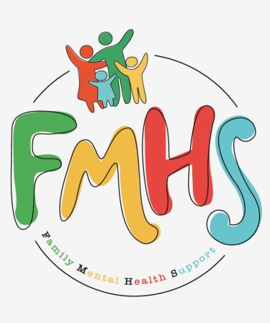
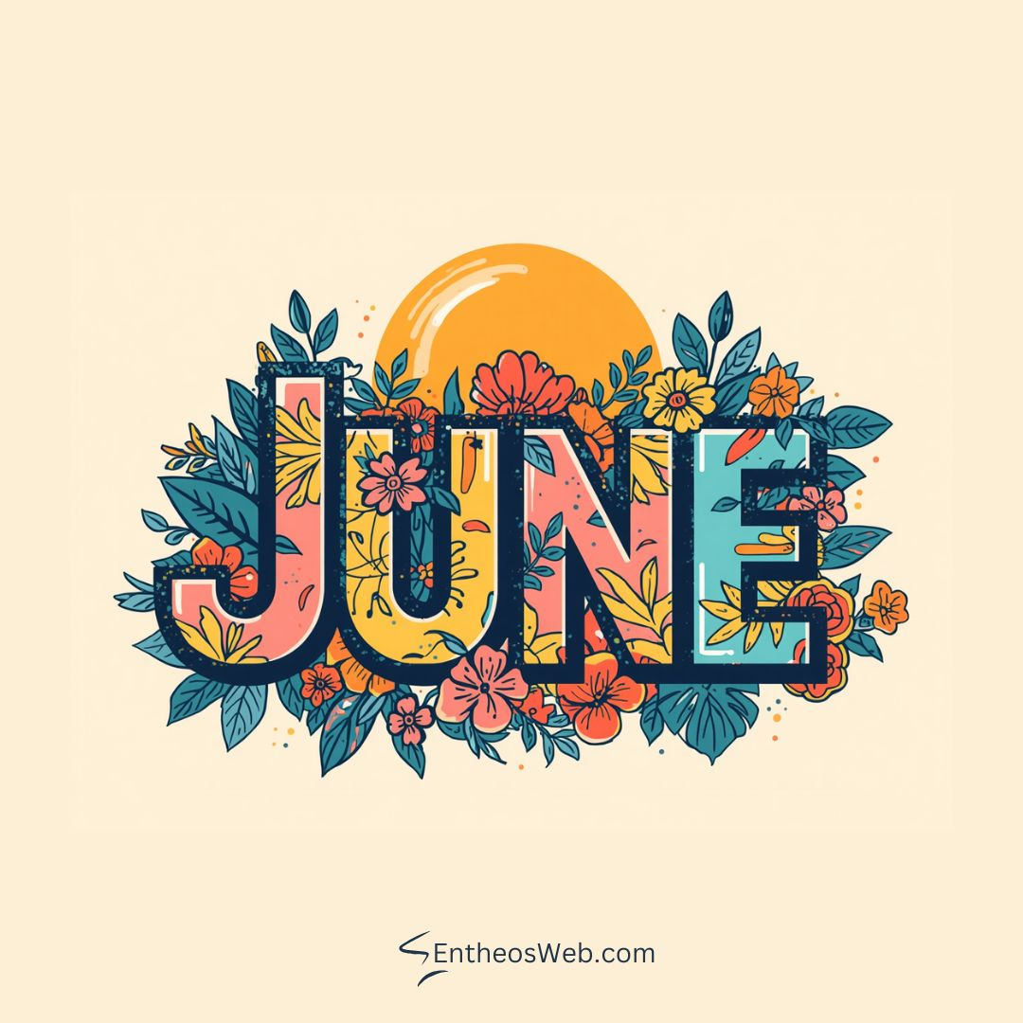
Volume 7, Issue 5
May 2026

CHAT

THE OFFICE IS OPEN TUESDAYS & WEDNESDAYS 10-2.

Have some extra time on your hands? Consider volunteering at our office! Call Sue at:217-821-7737.



FMHS
Susan Elke, President
Sue Heth, V.P.
Maria Soutar, Secretary
Karen Dorn, Treasurer

INSIDE THIS ISSUE

- NEW HOURS
- Book Fundraiser
- Donations
- Recipe: Easy Fruit Salad
- Dates to Remember
- QR Code for the Website!!!!

FMHS BOOK FUNDRAISERS

WRITTEN BY LOCAL AUTHORS
Mary Ellen Eversman & Carol Johnson

DRAWN TOGETHER was written by Mary Ellen Eversman. This book recognizes the struggle and need to address children’s mental health issues.
THE HEALING POWER OF WORDS IN RHYME was written by Rev. Carol Johnson. It represents years of “penned” life experiences….a full range of joys and sorrows, ups and downs, challenges and respite points! Hopefully the reader will find comfort and encouragement through the shared life experiences.
The books are available in the FMHS office located at 202 N Banker, Effingham, IL. Drawn Together $8.50, and The Healing Power of Words in Rhyme $20.00. All proceeds go to continuing to provide information, guidance, and resources to our area’s citizens in their time of need!

FMHS WEBSITE
QR CODE
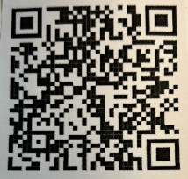

- QR is short for quick response. QR gives you an instant link to a specific webpage.
- Use the QR Code to easily access the CHAT, monthly newsletter.
- It’s easy to pass on to others.

Mental Health Resource on YouTube: Abide.com Suggested by Brenda Mundt

https://r.search.yahoo.com/_ylt=AwrFRtTrIx5qbxgBnmUPxQt.;_ylu=Y29sbwNiZjEEcG9zAzEEdnRpZAMEc2VjA3Ny/RV=2/RE=1781569771/RO=10/RU=https%3a%2f%2fabide.com%2fprayer%2fhui2ox/RK=2/RS=WV86cPZX5E_2brh_PayaUKla3cA-

A HEARTFELT THANKS

To FMHS Volunteers, who have been helping man the office, bringing treats and water to share, dusting, rearranging furniture, watering plants, mail pick up, and repairs! ...Your contributions keep us going!
Robert McWhorter, Maria Soutar, Susan Elke, Carol Johnson & Chuck Suttle, Patty Winn, Donnie & Karen Dorn, Rhonda & Dail Schonshack, and Luella Baker.
Thanks for the puzzles! They provide hours of entertainment for everyone and the misc. office supplies!
Special thanks to Debby Lamb, Dave Bloemer, & Kolton Howell for assisting with April & May “Invite the Healing” sessions with Carol Johnson.
Thank you, Brenda Mundt, for introducing us to a holistic resource about mental health. Abide.com

In Kind Contribution: Phone/Sue Heth
Donations:
Loella Baker—donuts for the Veteran’s Group
DAVA—funding for pizza for Veterans.
Bob McWhorter: coffee
Mike & Sonya: Art & Crafts supplies
Long Term Supporters:
100+ Women Who Care
United Way of Effingham County
OFFICE WISH LIST:
13 gallon trash bags

Easy Fruit Salad
Julieseatsandtreats.com

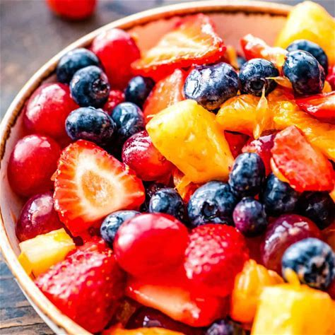

Strawberries (hulled & sliced) 1 pound
Blueberries, 11 ounces
Red Grapes, 3 cups
Whole Pineapple, sliced, 1
Mandarin Oranges (drained, 1 15oz can)
Instant Vanilla Pudding Powder, (not prepared) 2 tablespoons
Vanilla Extract, 1 teaspoon
Almond Extract, ½ teaspoon



DATES TO REMEMBER!

June 2, 3, 9, 10, 16, 17, 23, 24, & 30th ………….10-2pm Office open

June 17th ……...”Invite the Healing”—Sunlight/Moonlight Therapy
by Carol Johnson—5-7pm @ FMHS Office

June 24th……..”Invite the Healing”—Physical Therapy by Carol Johnson—5-7pm @
FMHS Office

June 2nd and 16th ……………The Society for Better Men Group, FMHS Office 7pm

June 11th and 25th ............10-12pm Veterans Support Group, FMHS Office

June 11th …..FMHS Monthly Support Group, 5:30-7:00pm, First Baptist Church of
Effingham—Guest Speaker, Michelle Barber, SWAN Inc.

June 23rd & 30th …………Anxiety/Mood Support Group, 5:30-6:30pm,
Effingham Public Library-Basement

June 17th ………..The Power of Song in Democracy with Chris Vallillo 5:00-6:30pm
at Effingham Public Library--Workman Room (Music & Community
Conversation)

June 25th …………………………Listen to your Heart Discussion Group, 5:30-6:30pm
by Greg Hook, FMHS Office

June 30th ………… Inspiration Discussion Group 1:00 @ FMHS office

