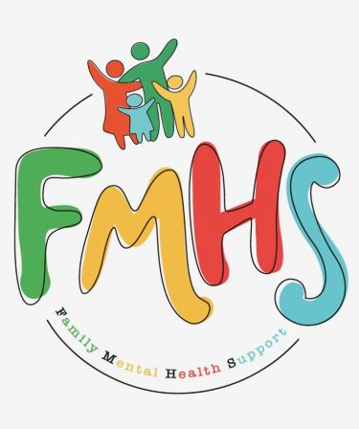
Volume 7, Issue 8
August 2026


CHAT

THE OFFICE IS OPEN TUESDAYS & WEDNESDAYS 10-2.

Have some extra time on your hands? Consider volunteering at our office! Call Sue at:217-821-7737.



The office will be closed week of Aug 1-8th because we will be at the Effingham County Fair. Come see us at the Schutzenfest Bldg.

FMHS
Susan Elke, President
Sue Heth, V.P.
Maria Soutar, Secretary
Karen Dorn, Treasurer

INSIDE THIS ISSUE

- NEW HOURS
- Book Fundraiser
- Donations
- Recipe: Sonya’s Summer Squash
- Dates to Remember
- QR Code for the Website!!!!

FMHS BOOK FUNDRAISERS

WRITTEN BY LOCAL AUTHORS
Mary Ellen Eversman & Carol Johnson

DRAWN TOGETHER was written by Mary Ellen Eversman. This book recognizes the struggle and need to address children’s mental health issues.
THE HEALING POWER OF WORDS IN RHYME was written by Rev. Carol Johnson. It represents years of “penned” life experiences….a full range of joys and sorrows, ups and downs, challenges and respite points! Hopefully the reader will find comfort and encouragement through the shared life experiences.
The books are available in the FMHS office located at 202 N Banker, Effingham, IL. Drawn Together $8.50, and The Healing Power of Words in Rhyme $20.00. All proceeds go to continuing to provide information, guidance, and resources to our area’s citizens in their time of need!

FMHS WEBSITE
QR CODE
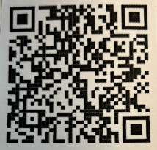

- QR is short for quick response. QR gives you an instant link to a specific webpage.
- Use the QR Code to easily access the CHAT, monthly newsletter.
- It’s easy to pass on to others.

DONATIONS

UNITED WAY of Effingham County

988 Suicide & Crisis Lifeline
- Call or Text or Chat the 988 Suicide & Crisis Lifeline
988. Hours are available 24/7 and the cost is free.

A HEARTFELT THANKS

To FMHS Volunteers, who have been helping man the office, bringing treats and water to share, dusting, rearranging furniture, watering plants, mail pick up, and repairs! ...Your contributions keep us going!
Robert McWhorter, Maria Soutar, Susan Elke, Carol Johnson & Chuck Suttle, Patty Winn, Donnie & Karen Dorn, Rhonda & Dail Schonshack, and Luella Baker.
Thanks for the puzzles! They provide hours of entertainment for everyone and the misc. office supplies!

In Kind Contribution: Phone/Sue Heth
Donations:
Loella Baker—donuts for the Veteran’s Group
DAVA—funding for pizza for Veterans.
Bob McWhorter: coffee
Mike & Sonya: Chair covers
Long Term Supporters:
100+ Women Who Care
United Way of Effingham County
OFFICE WISH LIST:
13 gallon trash bags



DATES TO REMEMBER!
August 1-8th …… Effingham County Fair @ Schutzenfest Building

August 3rd …… Mobile Justice Tour 2:00 -4:30pm Effingham Public Library
(parking lot) Land of Lincoln Legal Aid van travels across central and southern Illinois, bringing free civil legal services directly to the communities than need them most.

August 4, 11, 18 & 25th …………Anxiety/Mood Support Group, 5:30-6:30pm,
Effingham Public Library-Basement

August 7th @ 1:00-2:00 Effingham Public Library “Here, There, and Everywhere
with Jay Daniels” Join pianist and vocalist Jay Daniels through three iconic Beatles albums.

August 11, 12, 18, 19, 25, & 26th ………….10-2pm Office open

August 12th ……...”Invite the Healing”— Meditation/Focus Therapy by
Carol Johnson—5-7pm @ FMHS Office

August 13th and 27th ............10-12pm Veterans Support Group, FMHS Office

August 13th …..FMHS Monthly Support Group, 5:30-7:00pm, First Baptist Church of
Effingham—Guest Speaker, Tommy Alsobrooks @ Oxford House

August 18th ……………The Society for Better Men Group, FMHS Office 7pm

August 19th……..”Invite the Healing”— Personality Tests and Self Understanding
by Carol Johnson—5-7pm @ FMHS Office

August 23rd …………………………Listen to your Heart Discussion Group, 5:30-6:30pm
by Greg Hook, FMHS Office

August 27th ………… Inspiration Discussion Group 1:00 @ FMHS office

August 27th ….. Understanding the Conflict in Iran with Ryan Ervin @ 6:00-
7:00pm Effingham Public Library-- Gain a deeper understanding of the war involving Iran.
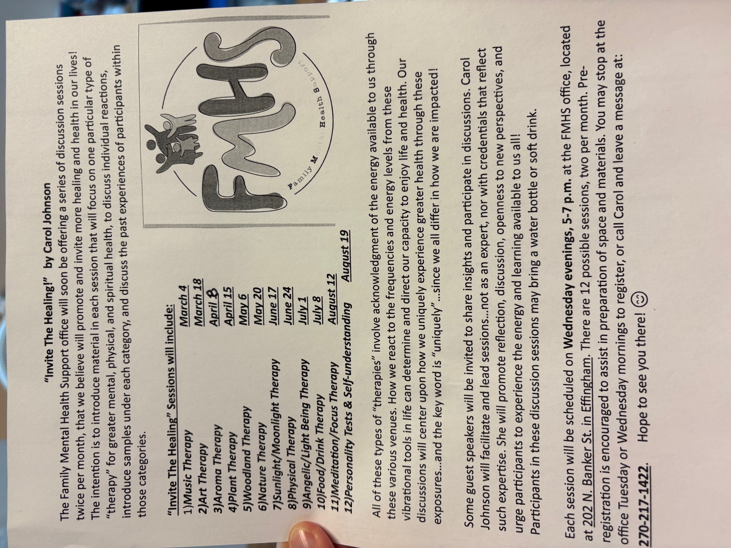
Sonya’s Summer Squash
Ingredients:
2 summer squash—halved
3/4 c shredded parmesan cheese (divided)
½ stick butter
seasoning
- Heat air fryer to 350
- Cut 2 medium squash or zucchini in half lengthwise
- Scoop out the middle seeds with a spoon to make a boat shape
- Chop up the middle portions of squash and mix with ½ stick melted butter, ½ c parmesan cheese and seasoning (I use Cavender’s Greek seasoning)
- Fill boats and top with remaining cheese
- Place in basket and air fry for 10-12 minutes. Watch closely! Cooking times vary.
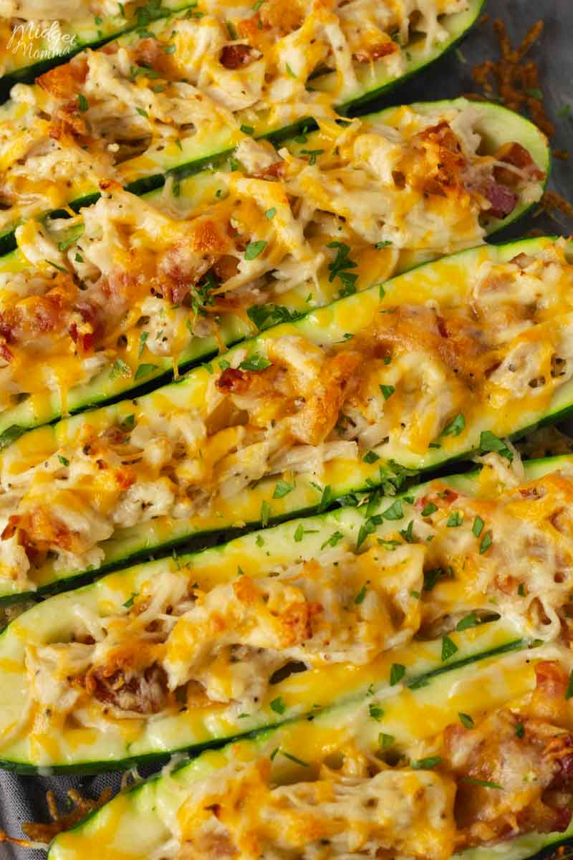
This Photo by Unknown Author is licensed under CC BY-SA-NC

988 Suicide & Crisis Lifeline
- Call or Text or Chat the 988 Suicide & Crisis Lifeline
988. Hours are available 24/7 and the cost is free.
- OR
Text HOME to 741741 to reach a trained Crisis Counselor through Crisis Text Line, a global not-for-profit organization. Free, 24/7, confidential.

