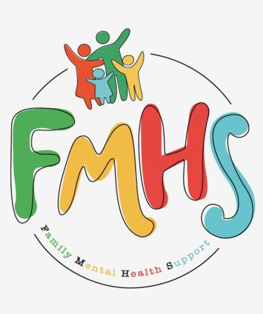

Volume 7, Issue 7
July 2026

CHAT

THE OFFICE IS OPEN TUESDAYS & WEDNESDAYS 10-2.

Have some extra time on your hands? Consider volunteering at our office! Call Sue at:217-821-7737.

FMHS
Susan Elke, President
Sue Heth, V.P.
Maria Soutar, Secretary
Karen Dorn, Treasurer

INSIDE THIS ISSUE

- NEW HOURS
- Book Fundraiser
- Donations
- Recipe: Easy Fruit Salad
- Dates to Remember
- QR Code for the Website!!!!

FMHS BOOK FUNDRAISERS

WRITTEN BY LOCAL AUTHORS
Mary Ellen Eversman & Carol Johnson

DRAWN TOGETHER was written by Mary Ellen Eversman. This book recognizes the struggle and need to address children’s mental health issues.
THE HEALING POWER OF WORDS IN RHYME was written by Rev. Carol Johnson. It represents years of “penned” life experiences….a full range of joys and sorrows, ups and downs, challenges and respite points! Hopefully the reader will find comfort and encouragement through the shared life experiences.
The books are available in the FMHS office located at 202 N Banker, Effingham, IL. Drawn Together $8.50, and The Healing Power of Words in Rhyme $20.00. All proceeds go to continuing to provide information, guidance, and resources to our area’s citizens in their time of need!

FMHS WEBSITE
QR CODE
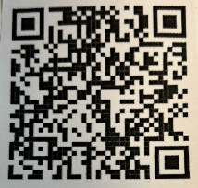

- QR is short for quick response. QR gives you an instant link to a specific webpage.
- Use the QR Code to easily access the CHAT, monthly newsletter.
- It’s easy to pass on to others.

MEMORIAL DONATION

SUSAN ELKE

A HEARTFELT THANKS

To FMHS Volunteers, who have been helping man the office, bringing treats and water to share, dusting, rearranging furniture, watering plants, mail pick up, and repairs! ...Your contributions keep us going!
Robert McWhorter, Maria Soutar, Susan Elke, Carol Johnson & Chuck Suttle, Patty Winn, Donnie & Karen Dorn, Rhonda & Dail Schonshack, and Luella Baker.
Thanks for the puzzles! They provide hours of entertainment for everyone and the misc. office supplies!

In Kind Contribution: Phone/Sue Heth
Donations:
Loella Baker—donuts for the Veteran’s Group
DAVA—funding for pizza for Veterans.
Bob McWhorter: coffee
Mike & Sonya: Art & Crafts supplies
Long Term Supporters:
100+ Women Who Care
United Way of Effingham County
OFFICE WISH LIST:
13 gallon trash bags

Struggle with Bi-polar
From: Bp-Hope

Ye (Kanye West)
Perhaps no artist has tied their public identity more closely to their diagnosis than Ye. He first revealed his bipolar disorder around the release of his 2018 album Ye, famously featuring the handwritten phrase, “I Hate Being Bipolar; it’s Awesome” on the album cover. Ye has frequently referred to his condition as a “superpower,” arguing that his manic phases drive his creative genius.
Yet, he’s also been candid about the severe downsides, describing the condition as a “sprained brain” and opening up about the intense paranoia and erratic behavior that accompany his acute manic episodes. While his relationship with consistent medication has been famously turbulent, his highly publicized struggles have forced mainstream media to repeatedly confront the complexities of severe mood disorders.

From: Everyday Health

How Using Your Brain Builds Cognitive Reserve and Neuroplasticity
Cognitive reserve is the brain’s ability to be agile, solve problems, take on challenges, and resist injury due to trauma, stroke, or aging. Although researchers don’t totally understand how a person gets or improves on “brain resilience,” it seems to be a combination of the brain we were born with and how we do — or don’t — use it.
“It appears that by cognitively challenging yourself, you can expand your cognitive reserve,” says Shehroo Pudumjee, PhD, a neuropsychologist at Cleveland Clinic Lou Ruvo Center for Brain Health in Las Vegas.
Neuroplasticity is the brain’s ability to form and modify neural connections. Improving or maintaining neuroplasticity can help in times of injury or disease and in learning and assimilating new information.
Continuing to learn and engage in activities can build on the advantages of neuroplasticity, which keeps the brain healthy and might limit the effects of neurodegenerative diseases like Alzheimer’s disease, says Dr. Pudumjee

Why Variety Is Best When It Comes to Exercising Your Brain
There’s probably no single brain exercise or game that, on its own, will prevent you from ever getting dementia, says Justin Miller, PhD, professor of neurology at the University of Washington School of Medicine and a neurologist at UW Medicine in Seattle.
“The way that I approach things when I work with patients is to look at the collective influence of all the different things that together can make a positive impact on keeping the brain healthy,” says Dr. Mille



DATES TO REMEMBER!

July 1, 7, 8, 14, 15, 21, 22, 28, & 29th ………….10-2pm Office open

July 1st ……...”Invite the Healing”— Food/Drink Therapy by Betty Sipes &
Carol Johnson—5-7pm @ FMHS Office

July 2 ……..America 250: The Story of 1776 – with Ryan Ervin & Effingham County
Cultural Center & Museum – 6:00-7:00pm @ 100 E. Jefferson Ave,
Effingham

July 8th……..”Invite the Healing”— Angelic/Light Being Therapy by Carol
Johnson—5-7pm @
FMHS Office

July 3rd ……. USA 250 Let Freedom RingCookout, Courthouse Lawn—Downtown
Effingham 11:00-1:00pm. Live Music by “Lady Liberty” PROCEEDS
BENEFIT: 2026 TURKEY DROP FOR VETERENS

July 21st ……………The Society for Better Men Group, FMHS Office 7pm

July 9th and 23rd ............10-12pm Veterans Support Group, FMHS Office

July 9th …..FMHS Monthly Support Group, 5:30-7:00pm, First Baptist Church of
Effingham—Guest Speaker, Heather Greenwood, Partners for Progress
Deflection Initiative.

July 9th …….. America 250: Honoring Declaration & American Revolution – with
The Daughters of the Revolution @ 6:00pm-7:00pm Effingham Public
Library – Workman Room

July 7, 14, 21 & 28th …………Anxiety/Mood Support Group, 5:30-6:30pm,
Effingham Public Library-Basement

July 16th ……. Vietnam War – Ronald Goddard @ Effingham County Cultural Center and Museum 100 E Jefferson Ave, Effingham

July 17th ………..The Power of Song in Democracy with Chris Vallillo 5:00-6:30pm
at Effingham Public Library--Workman Room (Music & Community
Conversation)

July 23rd …………………………Listen to your Heart Discussion Group, 5:30-6:30pm
by Greg Hook, FMHS Office

July 23rd ………… Inspiration Discussion Group 1:00 @ FMHS office

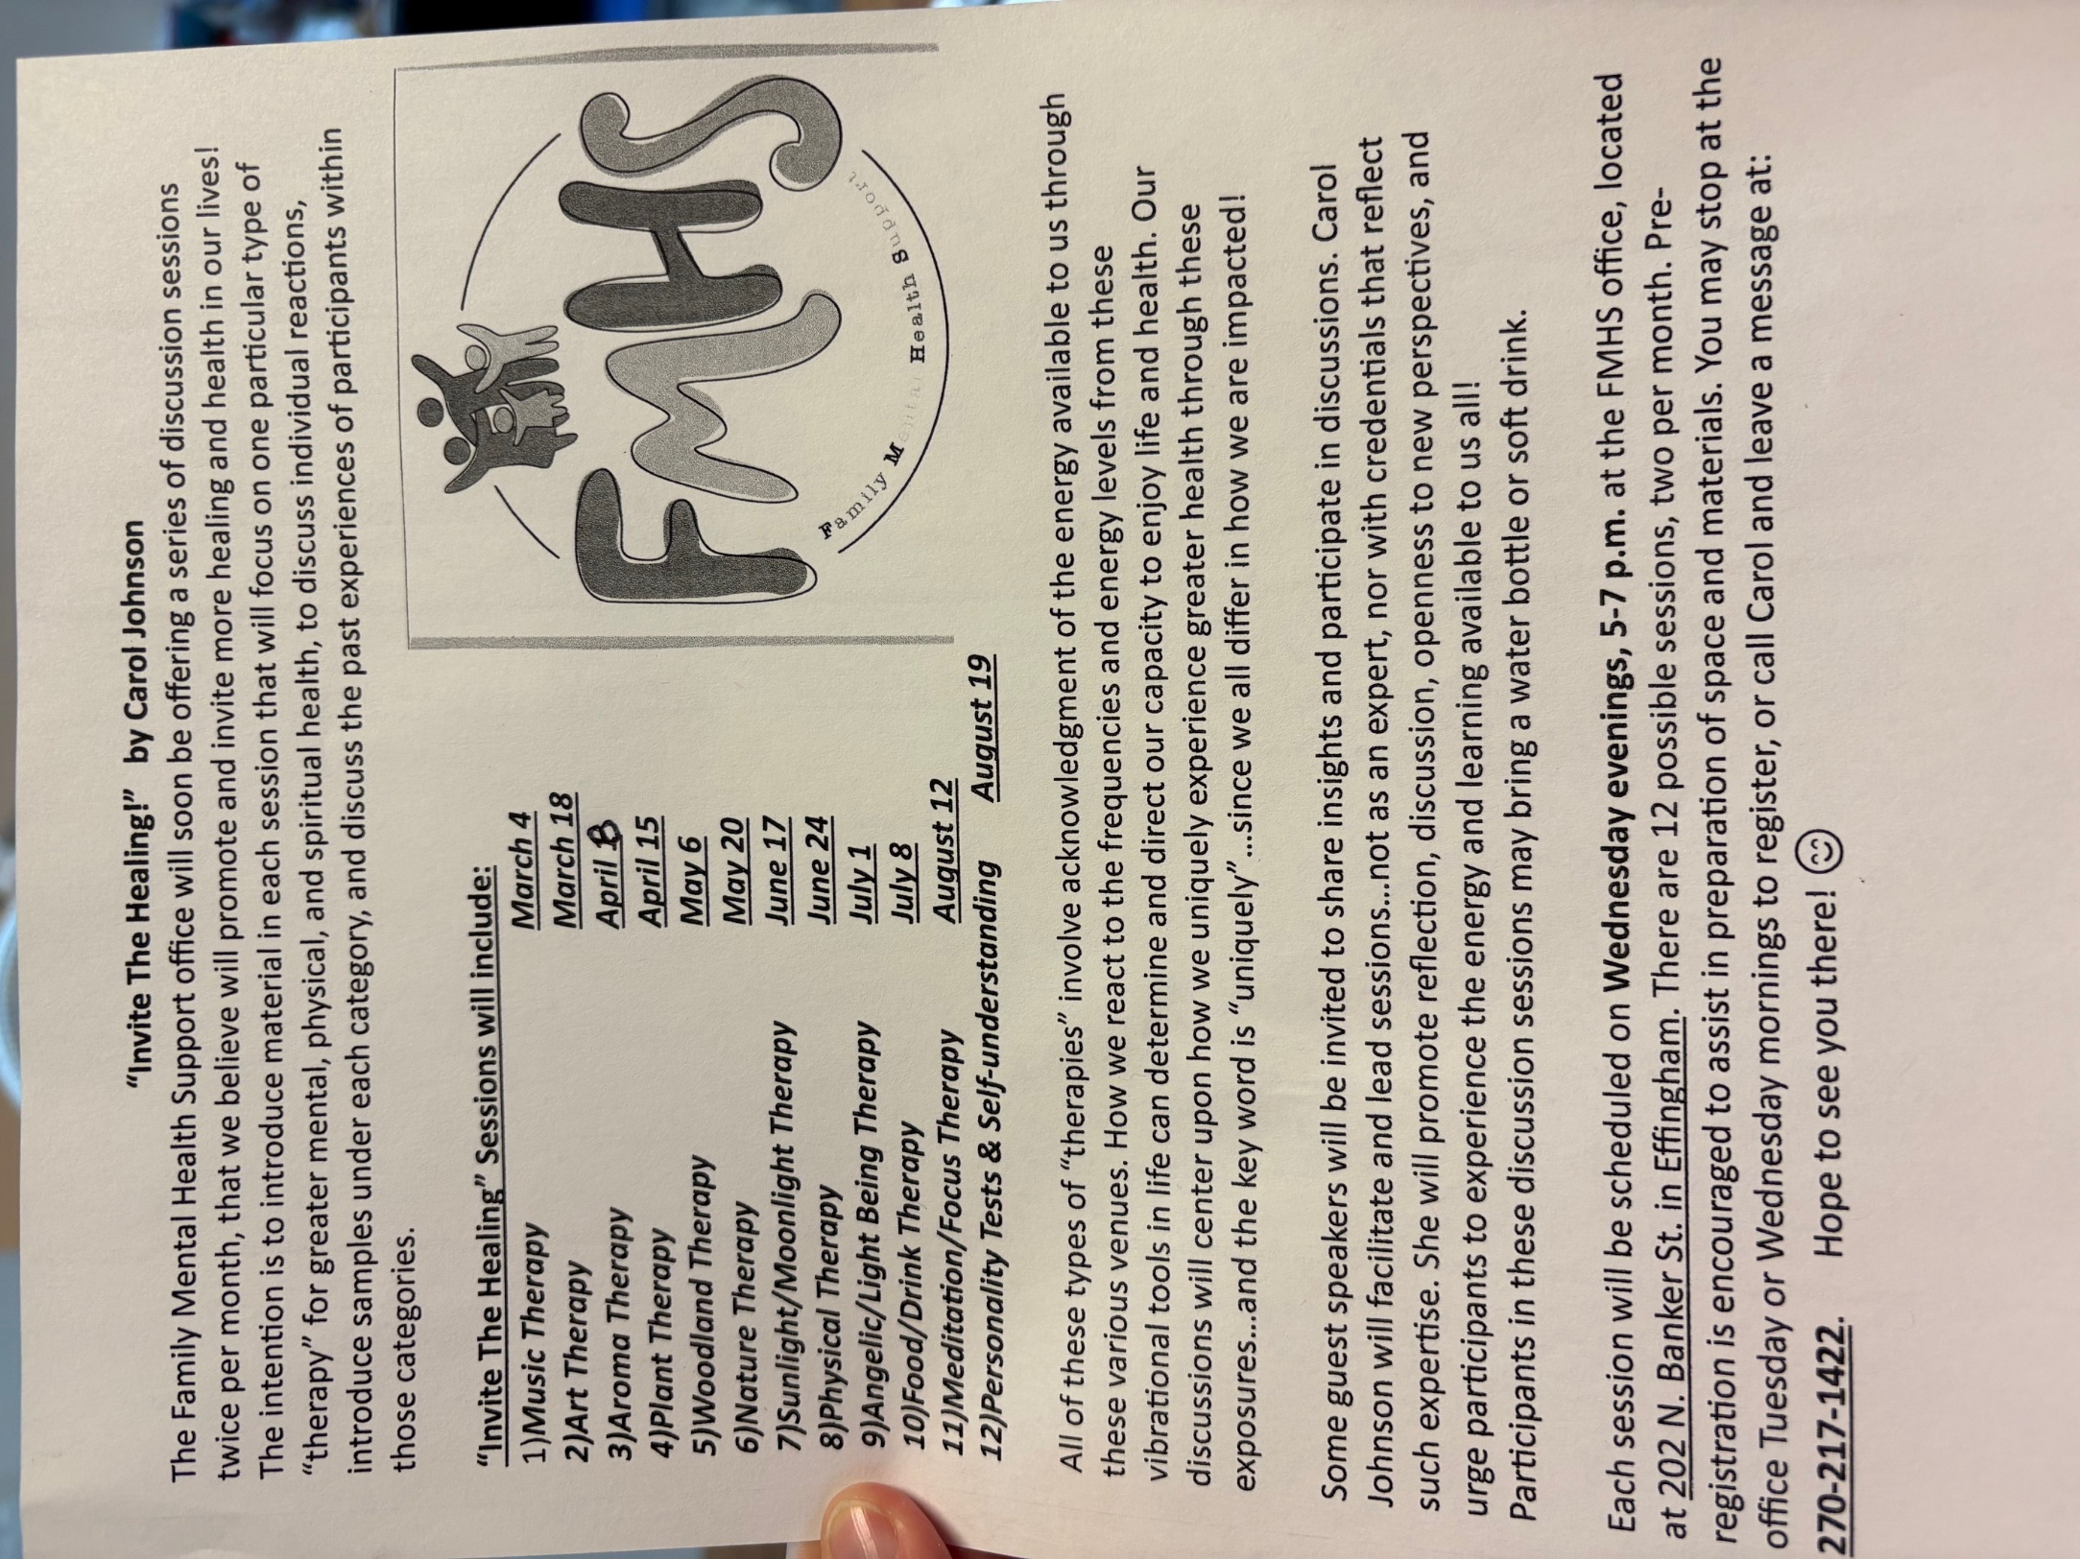
Sunny Seven Layer Summer Salad by “It’s only Recipes”
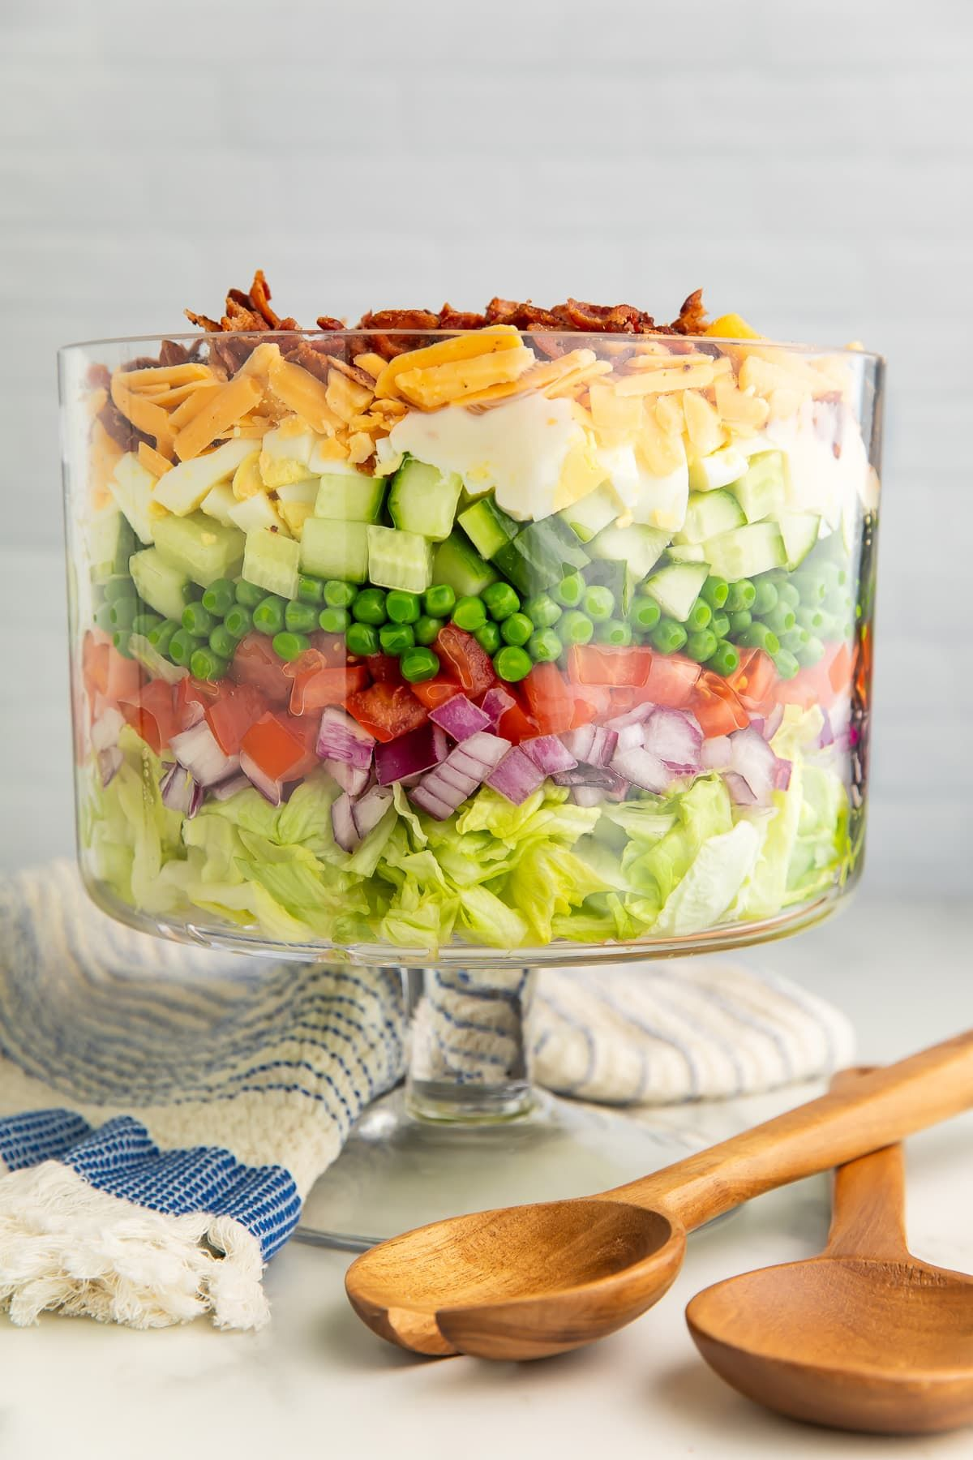
https://itsonly.recipes/view/sunny-seven-layer-summer-salad

