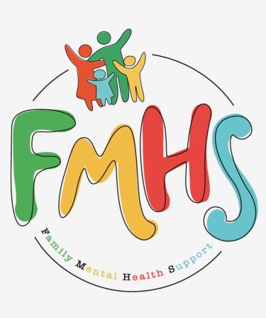
Volume 7, Issue 9
September 2026

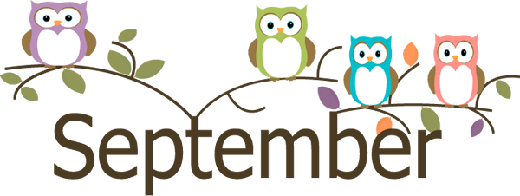
CHAT

THE OFFICE IS OPEN TUESDAYS & WEDNESDAYS 10-2.

Have some extra time on your hands? Consider volunteering at our office! Call Sue at:217-821-7737.
“Invite the Healing” has ended. Watch for updates as to the start of the next season of “The Chosen”. A huge THANK YOU to Pastor Carol Johnson for leading these groups.
SWAN is hosting a Caregiver Expo September 22nd, 10am at the Effingham Event Center. Lunch and door prizes. Contact Michelle Barber 217-342-4526 for more information.
Samantha Hicks will be the speaker for the FMHS Monthly Support Group. She will share re. her new position with Hour House. Mark your calendars!!

FMHS
Susan Elke, President
Sue Heth, V.P.
Maria Soutar, Secretary
Karen Dorn, Treasurer

INSIDE THIS ISSUE

- Memberships
- Donations
- Memorials
- Recipe: One Pot Goulash
- Dates to Remember
- QR Code for the Website!!!!
- Labor Day and
Mental Health

MEMBERSHIPS

Sonya & Mike Gammon
Maria Soutar
Katie & Jake Wernsing
Nicole & Brett Nuermberger
Krystle & Jon Greider
Joey Heth
Donna Harris
Kiley Heth
Josh Orem
Bob McWhorter
Sue Heth
A $10 FMHS Membership is a way the community can help support FMHS—a non-profit, all volunteer 501.C3 agency.

MEMORIALS

Carol Lance (Sue Heth)

FMHS WEBSITE
QR CODE
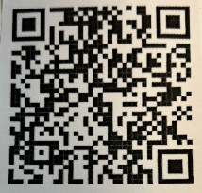

- QR is short for quick response. QR gives you an instant link to a specific webpage.
- Use the QR Code to easily access the CHAT, monthly newsletter.
- It’s easy to pass on to others.

DONATIONS

UNITED WAY of Effingham County

988 Suicide & Crisis Lifeline

- Call or Text or Chat the 988 Suicide & Crisis Lifeline
988. Hours are available 24/7 and the cost is free.
- OR
Text HOME to 741741 to reach a trained Crisis Counselor through Crisis Text Line, a global not-for-profit organization. Free, 24/7, confidential.

DID YOU HEAR ABOUT THE LABOR DAY JOKE?

…………It Doesn’t Work for Me!

A HEARTFELT THANKS

To FMHS Volunteers, who have been helping man the office, bringing treats and water to share, dusting, rearranging furniture, watering plants, mail pick up, and repairs! ...Your contributions keep us going!
Robert McWhorter, Maria Soutar, Susan Elke, Carol Johnson & Chuck Suttle, Patty Winn, Donnie & Karen Dorn, Rhonda & Dail Schonschack, and LoElla Baker.
Thanks for the puzzles! They provide hours of entertainment for everyone and the misc. office supplies!

In Kind Contribution: Phone/Sue Heth
Donations:
LoElla Baker—donuts for the Veteran’s Group
DAVA—funding for pizza for Veterans.
Bob McWhorter: coffee
Mike & Sonya: Chair covers
Long Term Supporters:
100+ Women Who Care
United Way of Effingham County
OFFICE WISH LIST:
13 gallon trash bags



DATES TO REMEMBER!

September 1, 2, 8, 9, 15, 16, 22, 23,29,30 The office is open 10-2 pm

September 10th & 24th ............10-12pm Veterans Support Group, FMHS Office

September 10th …..FMHS Monthly Support Group, 5:30-7:00pm, First Baptist Church of Effingham. Guest Speaker, Samantha Hicks, Hour House

September 20th ……………The Society for Better Men Group, FMHS Office 7pm

September 22nd………………..Inspiration Group, FMHS Office 1-2pm
ONE POT GOULASH
- 1 1/2 pound ground beef
- 1 onion, chopped
- 1 (8-ounce) package uncooked elbow macaroni
- 2 cups beef broth
- 1 (14-1/2-ounce) can diced tomatoes
- 1 (8-ounce) can tomato sauce
- 2 teaspoons garlic powder
- 1 teaspoon salt
- 1/2 teaspoon black pepper
What to Do
- In a soup pot over high heat, brown ground beef with onion 6 to 8 minutes, or until no pink remains in the beef, stirring frequently.
Stir in remaining ingredients and bring to a boil. Reduce heat to medium, cover, and simmer 7 to 8 minutes, or until macaroni is tender. Serve immediately. Note: We like to add a sprinkle of Parmesan cheese right before serving our goulash.
LABOR DAY
AND MENTAL HEALTH
Labor Day has a fascinating history, and there is a meaningful connection to mental health, stress, dignity, and the value of rest.
Labor Day is celebrated on the first Monday of September and honors the contributions and achievements of American workers.
The holiday grew out of the labor movement of the late 1800s, when many Americans worked extremely long hours—often 10–12 hours a day, six or seven days a week.
Although Labor Day wasn't created specifically as a mental-health holiday, its history has a strong connection to mental well-being.
1. Work can provide purpose—but too much work can cause harm.
Meaningful work can give people:
- Purpose
- Structure
- Social connection
- A sense of accomplishment
- Financial security
- A feeling that they are contributing to something larger than themselves
But when work becomes excessive or unhealthy, the opposite can occur.
Chronic workplace stress can contribute to:
- Anxiety
- Depression
- Burnout
- Sleep problems
- Irritability
- Relationship difficulties
- Physical health problems
The original labor movement was, in part, a response to conditions that left people physically and emotionally exhausted.
2. Rest is not laziness.
This may be one of the most important mental-health messages of Labor Day.
Our culture sometimes celebrates being busy. We can feel guilty when we're not accomplishing something.
But rest is part of being healthy.
A day away from work gives the mind an opportunity to slow down, reconnect with family and friends, enjoy nature, pursue hobbies, and simply breathe.
3. Labor Day reminds us of dignity.
One of the deeper messages of the labor movement was that people should not be valued solely for what they produce.
A person's worth is greater than their job title, salary, productivity, or accomplishments.
That's an important mental-health concept.
You are a human being before you are a worker.
4. Retirement can bring both freedom and challenges.
Labor Day can have a particularly interesting meaning for retirees.
After years of having a schedule and responsibilities, retirement can provide tremendous freedom—but it can also cause someone to wonder:
"If I'm no longer working, what is my purpose?"
Mental well-being in retirement often comes from replacing the structure and meaning that work once provided with other forms of purpose:
Connection + Service + Creativity + Learning + Spirituality + Recreation
Volunteering, helping others, spending time with family, participating in groups, gardening, traveling, creating art, or pursuing spiritual interests can all provide a sense of meaning.

