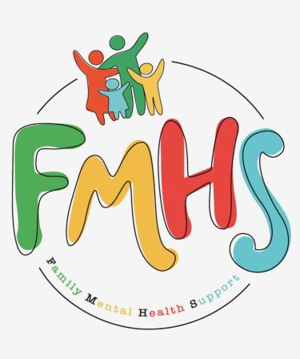
Volume 7, Issue 11
November 2026

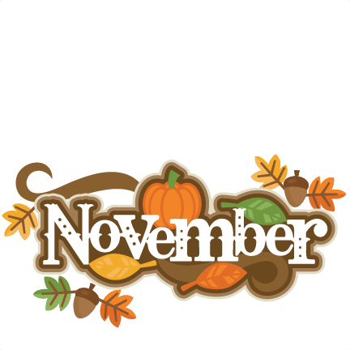
CHAT

THE OFFICE IS OPEN TUESDAYS 10-2

November is a busy and exciting time with faith, family, food, voting, and a time of recognizing our Veterans. It is also a time to realize that the fun activities can also be a source of stress….and to plan accordingly. It's a time to be kind to yourself.
Be sure to check out Carol’s Corner for an inspirational look at HARVEST AND THANKSGIVING.
Peggy, with the Effingham Library, is our speaker for the November Monthly Support Group. She leads the SWAG group—Seniors With an Attitude Group! Mark your calendars for Nov. 12.

Consider volunteering?
Call Sue at:217-821-7737

FMHS
Susan Elke, President
Sue Heth, V.P.
Maria Soutar, Secretary
Karen Dorn, Treasurer

INSIDE THIS ISSUE

- Memberships
- Donations
- Memorials
- Thanksgiving Blues
- Dates to Remember
- QR Code for the Website!!!!
- Carol’s Corner
- Recipe: Sweet potato pudding

DONATIONS:
Always tax deductible

MEMBERSHIPS:
($10—a way to support our
All volunteer, non-profit
Organization)

MEMORIALS:

FMHS WEBSITE
QR CODE
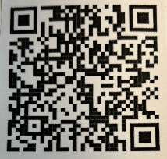

- QR is short for quick response. QR gives you an instant link to a specific webpage.
- Use the QR Code to easily access the CHAT, monthly newsletter.
- It’s easy to pass on to others.

A LAUGH FOR THE DAY

How is an ear of corn and an army alike?

(They both have a lot of kernels.)

988 Suicide & Crisis Lifeline

- Call or Text or Chat the 988 Suicide & Crisis Lifeline
988. Hours are available 24/7 and the cost is free.
Text HOME to 741741 to reach a trained Crisis Counselor through Crisis Text Line, a global not-for-profit organization. Free, 24/7, confidential.

A HEARTFELT THANKS

To FMHS Volunteers, who have been helping man the office, bringing treats and water to share, dusting, rearranging furniture, watering plants, mail pick up, and repairs! ...Your contributions keep us going!
Robert McWhorter, Maria Soutar, Susan Elke, Carol Johnson & Chuck Suttle, Patty Winn, Donnie & Karen Dorn, Rhonda & Dail Schonschack, and LoElla Baker.
Thanks for the puzzles! They provide hours of entertainment for everyone and the misc. office supplies!
Recognition, too, with a huge thanks to the numerous volunteers that share food for group activities. One of the Vet Group members said, “It’s like a family”….I couldn’t agree more!

In Kind Contribution: Phone/Sue Heth
Donations:
LoElla Baker—donuts for the Veteran’s Group
DAVA—funding for pizza for Veterans.
Bob McWhorter: coffee, water
Mike & Sonya: Chair covers
Long Term Supporters:
100+ Women Who Care
United Way of Effingham County
OFFICE WISH LIST:
Coffee

THANKSGIVING BLUES

Health experts warn that Thanksgiving can trigger a surge in depression and anxiety for some people, even as the holiday is celebrated for gratitude and togetherness.
The “forced sense of happiness” promoted by ads and social media can make those without close social connections or who have experienced loss feel left out, leading to sadness and withdrawal.
Stressors like hosting pressure, financial strain, and family conflict often overshadowing the positive effects of gratitude.
Symtoms Include: Persistent low mood or sadness,
Loss of energy or interest in activities, Appetite changes (overeating or loss of appetite), Social withdrawal and reduced communication.

Coping: Self-care and exercise to boost mood, Mindfulness and stress-reduction techniques like meditation or deep breathing, Setting realistic expectations and reframing what Thanksgiving means for you, Seeking professional support — schedule more frequent therapy sessions during the holidays,
Allowing mixed emotions — it’s healthy to feel both grateful and sad at the same time.



DATES TO REMEMBER!

November 3, 10, 17, 24 ………. The office is open 10-2 pm

November 3, 17…………..Anxiety/Mood Support Group 5:30-6:30
Effingham Public Library—Luttrell Room

November 12, ….......Veterans Support Group, 10-12
FMHS Office (Notice—our second mtg would have
been on Thanksgiving. Celebrate with your loved ones!

November 12 …..FMHS Monthly Support Group, 5:30-7:00pm, First Baptist
Church of Effingham. Guest Speaker, Peggy re. SWAG

November 19………….Listen to Your Heart by Greg Hook (Moved due to
Thanksgiving)

November 24………… Inspiration Group by Sue Heth, 1-2pm FMHS Office

November 26……….. 22nd Annual FISH Thanksgiving Day Dinner
Meals are offered free to Effingham County Residents.
Reservations Nov 1-24th at 217-994-1350
Location: Cornerstone Christian Church

CAROL’S CORNER

The Feast of Love”
by Carol Johnson
“I am the living bread that came down from Heaven.” John 6:51
Jesus’ words here make a strange declaration that He is not only from Heaven, but is actually sent to provide Himself as sustaining food for us! What a shock that must have been for the listeners of that region, those oppressed or used by the greedy and calloused Roman government. Yet, in our varied denominations, some form of this feeding takes place periodically, providing the miraculously spiritual food Jesus offered to all…not just a select few.
As we enter the season of harvest and Thanksgiving, we are drawn to think about food purchases, preparations, and feast-sharing! I am a southern woman who has been conditioned by a culture that tries to put food in the mouths of all who step into our home! Food is very much associated with family and friends, and meals provide time for REAL conversations (not technology-driven connections!) and the enjoyment of eating foods prepared with love.
There’s an old, beautiful European story of a young French refugee who appears in a coastal village, arriving with nothing, escaping war, seeking employment. Her family had all been killed. She had a letter of reference. Two elderly sisters alone in a large house agreed to take her in, for room and board. This caused much stirring in the community, since nothing new ever happened in their village! The people grumbled, gossiped, and questioned this new influence in their midst. The people had become splintered, and some held grudges for such a long time that there was diminished trust in their community, church, and families. But this new-comer grew to love them. She was known as a fantastic chef, creating extraordinary meals with even the simplest provisions. Gradually, her influence softened the people’s hearts. For the next 12 years, she lived and worked among them. The people agreed that she had brought new life to the once stagnant, resistant, stubborn community.
One day the young woman received a letter from France. A friend had for several years reentered her name in a lottery, and this year, her ticket had won! Everyone was happy she had won a lot of money, but were afraid she would now leave them!
She decided to have a great feast for the entire community with her winnings! She ordered the finest of ingredients and planned for a grand gathering for these people who seldom celebrated anything. And when the evening of the feast finally came, the magical effect of her gift of love swelled the hearts and warmed the coldness within them. They spoke together, forgave old grudges, laughed together, and experienced joy. One man said, “Tonight, friends, mercy and truth met together! Righteousness and bliss shall kiss one another.” And the people held hands, sang songs of faith, and a gentle snow began to fall covering the ground with white. It was as if they were all washed with forgiveness and grace.
It was only later that the aging sisters and all who attended realized that this feast (The Feast of Babette) had changed their hearts and lives. And then they discovered that the young woman had spent every penny she had, in their behalf. The feast had cost her everything, and cost nothing for the recipients. I like to think that is what true community looks like, the giving of self without counting the cost, the receiving with thankful hearts, the trust-building and respect reflected in how we speak of and with one another, and occasionally changing the way we think and even helping each other change sometimes! So thankful!

Sweet Potato Pudding
By Maria Do
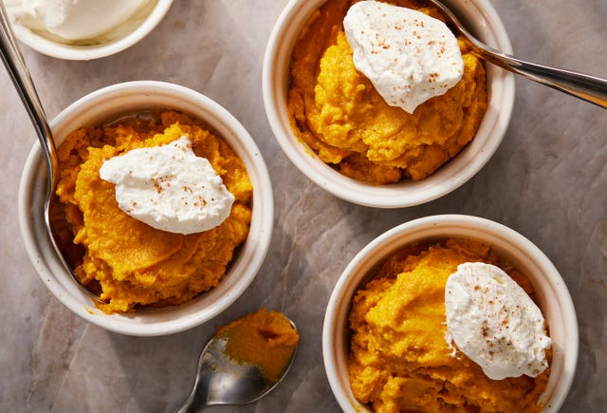

Ingredients
- 2 1/2 lb. sweet potatoes (about 4 large), peeled and cut into 1" cubes
- 4 Tbsp. unsalted butter, cubed
- 1 large egg
- 1/2 cup (105 g.) packed dark brown sugar
- 1/4 cup whole milk, evaporated milk, or full-fat coconut milk
- 1 tsp. kosher salt
- 1 tsp. pure vanilla extract
- 1/2 tsp. ground nutmeg
- Whipped cream or marshmallow fluff, for topping

Directions
  - Step 1 Arrange a rack in center of oven; preheat to 350º.
  - Step 2 In a large pot, place potatoes. Add enough water to cover potatoes by 1". Cover pot and bring to a boil over high heat. Once boiling, reduce heat to medium and cook at rapid simmer until potatoes are easily pierced with a paring knife, 10 to 12 minutes.
  - Step 3 Drain potatoes in a colander and transfer to a blender. Add butter and cover to let butter melt. Add egg, brown sugar, milk, salt, vanilla, and nutmeg and blend until smooth. Transfer potato mixture to an 8"-by-8" baking dish.
  - Step 4 Bake pudding until warmed through and lightly golden on top, 55 to 65 minutes. Let cool on a wire rack 1 hour.
  - Step 5 Serve at room temperature or refrigerate until cold. Divide pudding among small bowls or ramekins. Top with a dollop of cream.
** Pudding can be made 3 days ahead. Store in an airtight container and refrigerate.

WISHING YOU
A
HAPPY
THANKSGIVING!
