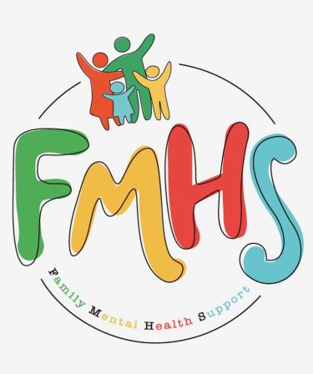
Volume 7, Issue 9
September 2026


CHAT

THE OFFICE IS OPEN TUESDAYS 10-2.

Have some extra time on your hands? Consider volunteering at our office! Call Sue at:217-821-7737.
“Invite the Healing” has ended. Watch for updates as to the start of the next season of “The Chosen”. A huge THANK YOU to Pastor Carol Johnson for leading these groups.

Laquita Campbell will be the speaker for the FMHS Monthly Support Group. She will share about Wholistic Health. Mark your calendars!!

FMHS
Susan Elke, President
Sue Heth, V.P.
Maria Soutar, Secretary
Karen Dorn, Treasurer

INSIDE THIS ISSUE

- Memberships
- Donations
- Memorials
- Recipe:
- Dates to Remember
- QR Code for the Website!!!!
- Labor Day and
Mental Health

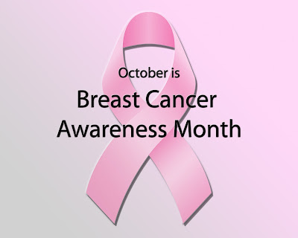
This Photo by Unknown Author is licensed under CC BY-NC-ND
DONATIONS:

Pampered Chef Fundraising

MEMBERSHIPS:

Sonya & Mike Gammon
Maria Soutar
Katie & Jake Wernsing
Nicole & Brett Nuermberger
Krystle & Jon Greider
Joey Heth
Donna Harris
Kiley Heth
Josh Orem
Bob McWhorter
Sue Heth
A $10 FMHS Membership is a way the community can help support FMHS—a non-profit, all volunteer 501.C3 agency.

MEMORIALS:

FMHS WEBSITE
QR CODE


- QR is short for quick response. QR gives you an instant link to a specific webpage.
- Use the QR Code to easily access the CHAT, monthly newsletter.
- It’s easy to pass on to others.

988 Suicide & Crisis Lifeline

- Call or Text or Chat the 988 Suicide & Crisis Lifeline
988. Hours are available 24/7 and the cost is free.
- OR
Text HOME to 741741 to reach a trained Crisis Counselor through Crisis Text Line, a global not-for-profit organization. Free, 24/7, confidential.

How do you mend a broken gourd?
--With a Pumpkin Patch

A HEARTFELT THANKS

To FMHS Volunteers, who have been helping man the office, bringing treats and water to share, dusting, rearranging furniture, watering plants, mail pick up, and repairs! ...Your contributions keep us going!
Robert McWhorter, Maria Soutar, Susan Elke, Carol Johnson & Chuck Suttle, Patty Winn, Donnie & Karen Dorn, Rhonda & Dail Schonschack, and LoElla Baker.
Thanks for the puzzles! They provide hours of entertainment for everyone and the misc. office supplies!

In Kind Contribution: Phone/Sue Heth
Donations:
LoElla Baker—donuts for the Veteran’s Group
DAVA—funding for pizza for Veterans.
Bob McWhorter: coffee
Mike & Sonya: Chair covers
Long Term Supporters:
100+ Women Who Care
United Way of Effingham County
OFFICE WISH LIST:
13 gallon trash bags



DATES TO REMEMBER!

October 6, 13, 20, 27 ………. The office is open 10-2 pm

October 6, 13, 20, 27th …………..Anxiety/Mood Support Group 5:30-6:30
Effingham Public Library
October 8th & 22th ............10-12pm Veterans Support Group, FMHS
Office

October 8th …..FMHS Monthly Support Group, 5:30-7:00pm, First Baptist
Church of Effingham. Guest Speaker, Laquita Campbell

October 10th ………………Clothing Swap 9:30-11:30am, Effingham Public
Library

October 13th …………Mobile Justice Tour w/ Land of Lincoln Legal Aid
2:00-4:30, Effingham Public Library

October 16th ………..Sculptures on the Avenues 10:00-11:00, Effingham
Public Library-The Café

October 20th ……………The Society for Better Men Group, FMHS Office
7pm

October 20th ………….Preserving History with Geoffrey Baer—Live via
Zoom 7:00-8:00 Effingham Public Library

October 22nd ………Medicare Class with Emily Garrard 5:30-6:15,
Effingham Public Library

October 27th………………..Inspiration Group, FMHS Office 1-2pm

October 31st …………. Wandering Widows, 9:00-11:00, Effingham Public
Library
PROGRESS --Anonymous
I didn’t make it up today
Just watched shadows on the wall
I took my meds and lay in bed
But didn’t die after all

I woke up on the green side
Then my pain crept in
Depression ruled all my thoughts
I slept the day away again

Despair fills my sleepless night
And darkness fills the day
I don’t know why I feel so bad
I want it to go away

I saw someone I love today
So, I put on a plastic smile
She talked to Jesus about me
She hopes I’ll stay awhile
I was sure the day was cloudy
I didn’t look out all day
Then the stupid sun poked thru
So… I put my booze away

Today’s the day I’ll make it
My feet will hit the floor
Today I will go outside
If I can Make it through the door

The sun felt warm upon my face
No shoes upon my feet
I was wearing last week’s clothing
Yet I accomplished a great feat

Maybe I will take a shower
Or watch my grandkids play some ball
Maybe I will call my Mom
And say…I made progress…after all

Impact of Fall on Mental Health

Fall can trigger various mental health issues, including seasonal affective disorder (SAD), due to shorter daylight hours and changes in routine. Many individuals may experience increased feelings of sadness or anxiety as the season shifts, impacting overall well-being.
Understanding how fall affects mental health is crucial.
- Seasonal Affective Disorder (SAD) — This condition affects many individuals during fall and winter months, leading to symptoms like depression and fatigue.
- Reduced Daylight — Shorter days can disrupt circadian rhythms, contributing to mood changes and lethargy.
- Routine Changes — The transition from summer to fall often alters daily routines, which can exacerbate feelings of anxiety or sadness.
- Coping Strategies — Engaging in outdoor activities and maintaining social connections can help mitigate negative mental health effects during this season.
https://r.search.yahoo.com/_ylt=A2RRMaA91L5qyQIAsOIPxQt.;_ylu=Y29sbwN1cy1lYXN0LTEEcG9zAzEEdnRpZAMEc2VjA3Nj/RV=2/RE=1792100670/RO=10/RU=https%3a%2f%2fwww.blueumbrellapsychiatry.com%2fembracing-fall-nurturing-mental-health-as-the-seasons-change/RK=2/RS=QDMzvgSiHQ06bxIkUdaviGQ4XE0-

Sweet Potato Pudding
By Maria Do
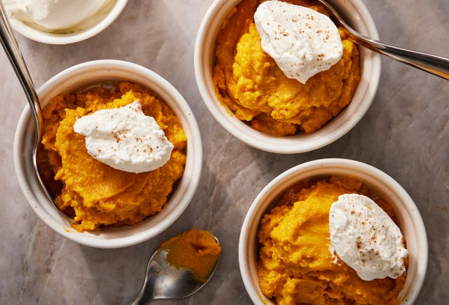

Ingredients
- 2 1/2 lb. sweet potatoes (about 4 large), peeled and cut into 1" cubes
- 4 Tbsp. unsalted butter, cubed
- 1 large egg
- 1/2 cup (105 g.) packed dark brown sugar
- 1/4 cup whole milk, evaporated milk, or full-fat coconut milk
- 1 tsp. kosher salt
- 1 tsp. pure vanilla extract
- 1/2 tsp. ground nutmeg
- Whipped cream or marshmallow fluff, for topping

Directions
  - Step 1 Arrange a rack in center of oven; preheat to 350º.
  - Step 2 In a large pot, place potatoes. Add enough water to cover potatoes by 1". Cover pot and bring to a boil over high heat. Once boiling, reduce heat to medium and cook at rapid simmer until potatoes are easily pierced with a paring knife, 10 to 12 minutes.
  - Step 3 Drain potatoes in a colander and transfer to a blender. Add butter and cover to let butter melt. Add egg, brown sugar, milk, salt, vanilla, and nutmeg and blend until smooth. Transfer potato mixture to an 8"-by-8" baking dish.
  - Step 4 Bake pudding until warmed through and lightly golden on top, 55 to 65 minutes. Let cool on a wire rack 1 hour.
  - Step 5 Serve at room temperature or refrigerate until cold. Divide pudding among small bowls or ramekins. Top with a dollop of cream.
** Pudding can be made 3 days ahead. Store in an airtight container and refrigerate.**

